**A**

**MINOR-PROJECT REPORT**

**ON**

Business-to-business (b2b) platform

**SUBMITTED BY**

KAJAL SINGH

(BSIT/16/027)

**GUIDED BY**

Prof. Bhaskar



**DEPTERTMENT OF BSC-IT**

**BVDU DITM**

**AMPLIFY MINDWARE- DITM , KATRAJ**

**Pune-411043**

**April 2018**

BHARTI VIDYAPEETH DEEMED UNIVERSITY

(YASHWANTRAO MOHITE COLLEGE ,PUNE)



**BHARTI VIDYAPEETH DEEMED UNIVERSITY**

**AMPLIFY Mindware-DITM , PUNE-411043**

**CERTIFICATE**

This is to certify that the Project entitled

**Business-to-business (b2b)platform**

SUBMITTED BY

KAJAL SINGH

(BSIT/16/027)

Of **SEMIV (BSC-IT)** is bonafide work carried out under the supervision work of **Prof.Bhaskar** and it is approved as the partial fulfillment of Minor Project and Seminar(MPS) as per the syllabus of BHARTI VIDYAPEETH DEEMED UNIVERSITY,AMPLIFY(YASHWANTRAO MOHITE COLLEGE,PUNE)

**Prof. Bhaskar Prof. Prashant Hinduja**

Project Guide Head of the

Department of ( BSC-IT)

**Acknowledgement**

The completion of any project brings with it a sense of satisfaction, but it is never complete without thanking those people who made this possible whose constant support has crowned our effort with success.

I avail this opportunity to express my sincere gratitude to all those people who contributed to this project .I am grateful to Prof, director for their continuous encouragement and support.

I would like to express my gratitude to PRASHANT HINDUJA, Head of the department of BSC-IT, for encouraging us to carry out the Minor Project.

I would also like to thank my guide, Prof. Bhaskar Anand, department of BSC-IT for the expert guidance, encouragement, valuable suggestions at every step and support towards the completion of MINIOR PROJECT.

KAJAL SINGH

(BSIT/16/027) SEM-IV

# **Title : Business-to-business(b2b)platform**

The main purpose of this project to provide fast, free, reliable and comprehensive information to our users and connect buyers to sellers. This site has two users: client and business.

**Key Highlights**

* Services offered across various cities and country
* Advanced and scalable technology platform
* Experienced management team
* Large online community for reviews
* Long operating history with a proven monetization mode

It is based on:

**Front End : HTML5**

**Back End : php 7, jquery ,ajax, bootstrap**

Objective of the project :-

The purpose of this site to search service bridges the gap between the users and businesses by helping users find relevant providers of products and services quickly, while helping businesses listed in project’s database to market their offerings. It has also initiated its ‘Search Plus’ Services for the users. These services are aimed at making several day-to-day tasks conveniently actionable and accessible to the users. With this step, project is transitioning from being purely a provider of local search and related information to being an enabler of such transactions. It intends to provide an online platform to thousands of SMEs to get them discovered and transacted.

A B2B (Business to Business) Trade Website is a new way of making Business on the internet. It works through many web portals that are known as B2B Websites or B2B Portals that have had a directory or list of products, suppliers, manufacturers, traders, distributors and wholesalers of all kinds of products across the world so that it helps buyers and suppliers to connect with each other across the globe. B2B Websites are very effective tool whether you have a small, medium or large sized business because it could manage your key business functions with other business vendors and partners through web-based applications. It serves as an effective platform for retailers, wholesalers, distributors and producers to carry out business activities online.

**Advantages of B2B Websites for Buyers:**

* Latest supplier catalogs, full company information and product profiles
* Product Alert e-mails when new products go online
* Inquiry basket: send inquiries quickly to multiple suppliers
* Evaluate suppliers, preview showcased product details
* Set appointments to meet suppliers, ahead of the show, online
* Qualify new suppliers who may not be attending the actual show
* Getting best price as there is no middleman between Buyer and Supplier, thus saving your money.

**Advantages of B2B Websites for Suppliers:**

* 24/7 specific industry marketing reach to the global community of merchandise trade buyers
* Marketing Website comprised of home page, company profile, electronic showroom, factory tour, code of conduct, research and development, quality control, management, trade shows, OEM capabilities and more...
* Create, manage and update own electronic catalog with full product information
* Improve buyer communications with address book and e-marketing functionality
* Access Market Intelligence reports - online customized information about buyers, competitors and market trends
* Maximize your efficiency - e-mail up-to-date product and company information to multiple buyers at one time
* Increased marketing visibility before, during and after each show
* Pre-announced participation at upcoming trade shows
* Online product promotion with show site at Trade Show Cente

***HARDWARE & SOFTWARE***

***REQUIREMENTS***





|  |
| --- |
| **Software Requirement during Development** |
|
| * Php * SQL Server 2015 Express Edition. * Windows XP (Service Pack 3), Window 7, Window Vista (ServicePack1). * PhpMyAdmin * PDO Connection   **Software Requirement after Development**   * XAAMP CONTROL PANEL * Windows XP (Service Pack 3), Window 7, Window Vista (Service Pack 1). * Apache, MySQL * PhpMyAdmin |
|  |

**Hardware Requirements**

**Hardware Requirement during Development**

* RAM (1GB).
* Hard disk (20 GB).
* CD ROM.
* Intel Core 2 DUO 1.6 GHZ Processor.

**Hardware Requirement after Development**

* RAM (1GB).
* Hard disk (20 GB).
* Intel Core 2 DUO 1.6 GHZ Processor.

*PROJECT PLANNING*

**Project Planning**

“The planning stage establishes a bird's eye view of the intended software product, and uses this to establish the basic project structure, evaluate feasibility and risks associated with the project, and describe appropriate management and technical approaches”

**Project planning** is part of Project Management. It is a well-established approach tomanaging and controlling the introduction of new initiatives or organizational changes. Projects are finite in length, usually one- time pieces of work involving a number of activities that must be completed within a given time frame, and often on a fixed budget.

While the very simplest projects can be managed easily by applying common sense and just getting on with things, projects that are more complex need a great deal of planning, and benefit from a formal, disciplined management approach. From making sure that activities will actually meet the specified need, to devising a workable schedule, developing systems for reporting progress, and managing requests for changes – all of these issues require thoughtful consideration. Managing projects well requires a great deal of time, skill, and finesse. There are many sides to project management and this is what makes it so interesting and demanding

**Application Goals**

User view

Register:

* New user can register with their email and other info .
* User can enter the company name and other basic details.
* User will receive activation mail.
* User can complete their registration by click activation link.

Login:

* User can login via registered Email and password.
* User has forgot password option to recover the account.

Home:

* User can view the search option on the home page itself.
* User can view the entire category list.
* User can view the popular services quick link under category.
* User can prospect the trending product detail.
* User can view the business & service category detail.
* User can view the featured listing details.
* User can view the testimonial of the satisfied customers.

Search:

* User can search for a particular product via search box.
* User can enter the product name and area.
* User can view the search result that can be sort by top results, location, distance, ratings and best deal.
* User can vary the view of the search result.
* User can view the options that has quick link to the product.

My account:

* My profile:
  + User can view the editable personal detail.
  + User can view the address detail.
  + User can add new address detail for both home and office.

.

* My favorite:
  + User can view the added favorite list.
  + User can add the product to the favorite list.
  + User can search for the product to add favorite list.
  + User can remove the added list.
* My membership:
  + User can view the membership plan detail.
* My rating:
  + User can view the rating detail.
* Change password:
  + Use can vary the password via this.
* My listing:
  + User can view and add the company information detail.
  + User can view and add the location information detail.
  + User can view and add the contact information detail.
  + User can view and add the payment/timing information detail.
  + User can add new business keyword to the list.
  + User can view the business keyword view.
  + User can view the business images, banner and logo.
  + User can view and manage the catalog detail.
  + User can request for some services as ECS/CCSI.
  + User can submit online request/complaint.

Category management:

* User can view the entire categories.
* User can view the sub categories by tapping the categories.
* User can sort by top results, location, distance, ratings and best deal.
* User can vary the view.
* User can view the options that has quick link to the product.

Careers:

* User can view some job details.
* User can view the categories.
* User can view the relevant job detail.

Contact us:

* User can view the contact detail.
* User can view the contact form to send feedback.

CMS page:

* About us.
* Follow us.

***DESIGN***



**DESIGN PHASE**

In systems, design functions and operations are described in detail, including screen layouts, business rules, process diagrams and other documentation. The output of this stage will describe the new system as a collection of modules or subsystems.

The design stage takes as its initial input the requirements identified in the approved requirements document. For each requirement, a set of one or more design elements will be produced as a result of interviews, workshops, and/or prototype efforts. Design elements describe the desired software features in detail, and generally include functional hierarchy diagrams, screen layout diagrams, tables of business rules, business process diagrams, pseudo code, and a complete entity-relationship diagram with a full data dictionary. These design elements are intended to describe the software in sufficient detail that skilled programmers may develop the software with minimal additional input.

**ADMIN**

Login Page

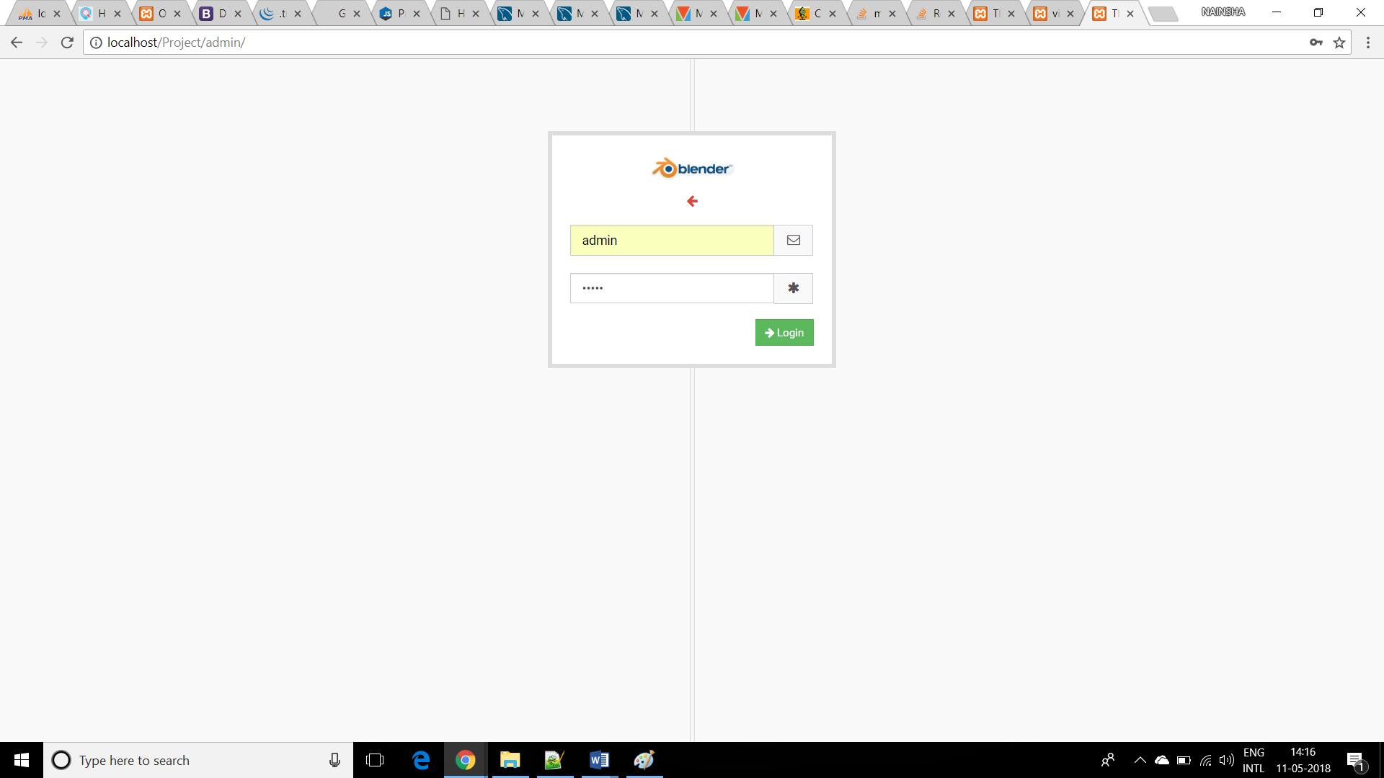

Home Page

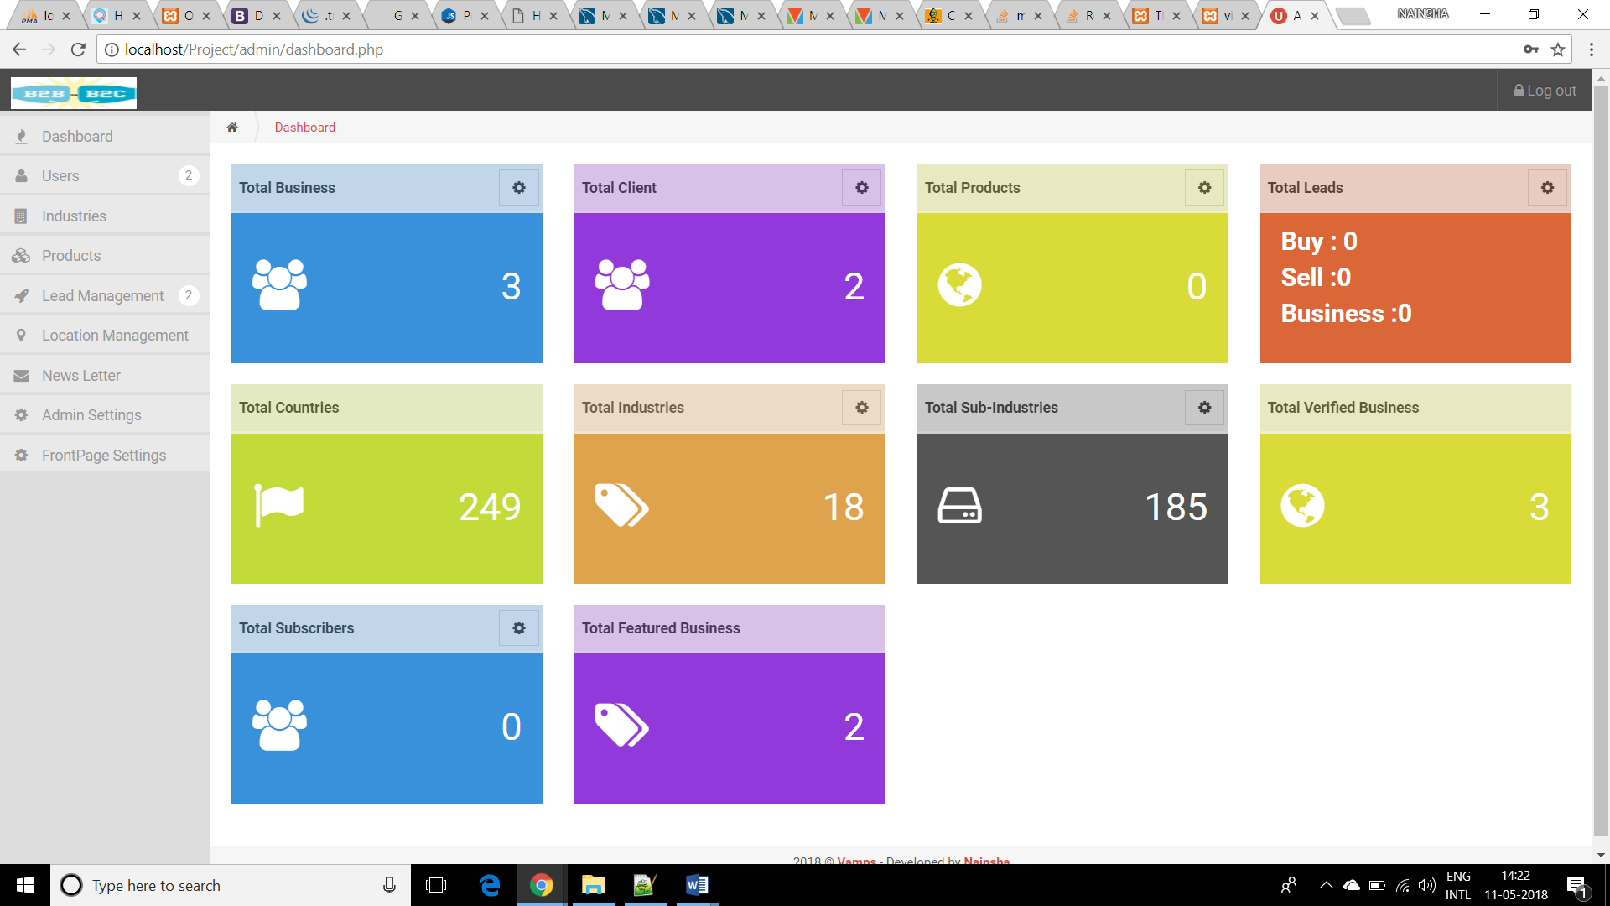

No. of Client Users

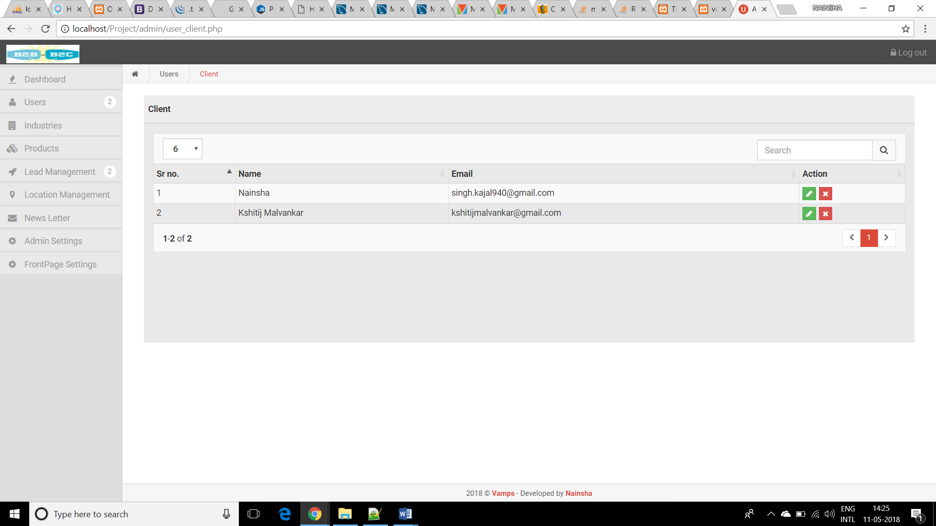

# No. of Business Users

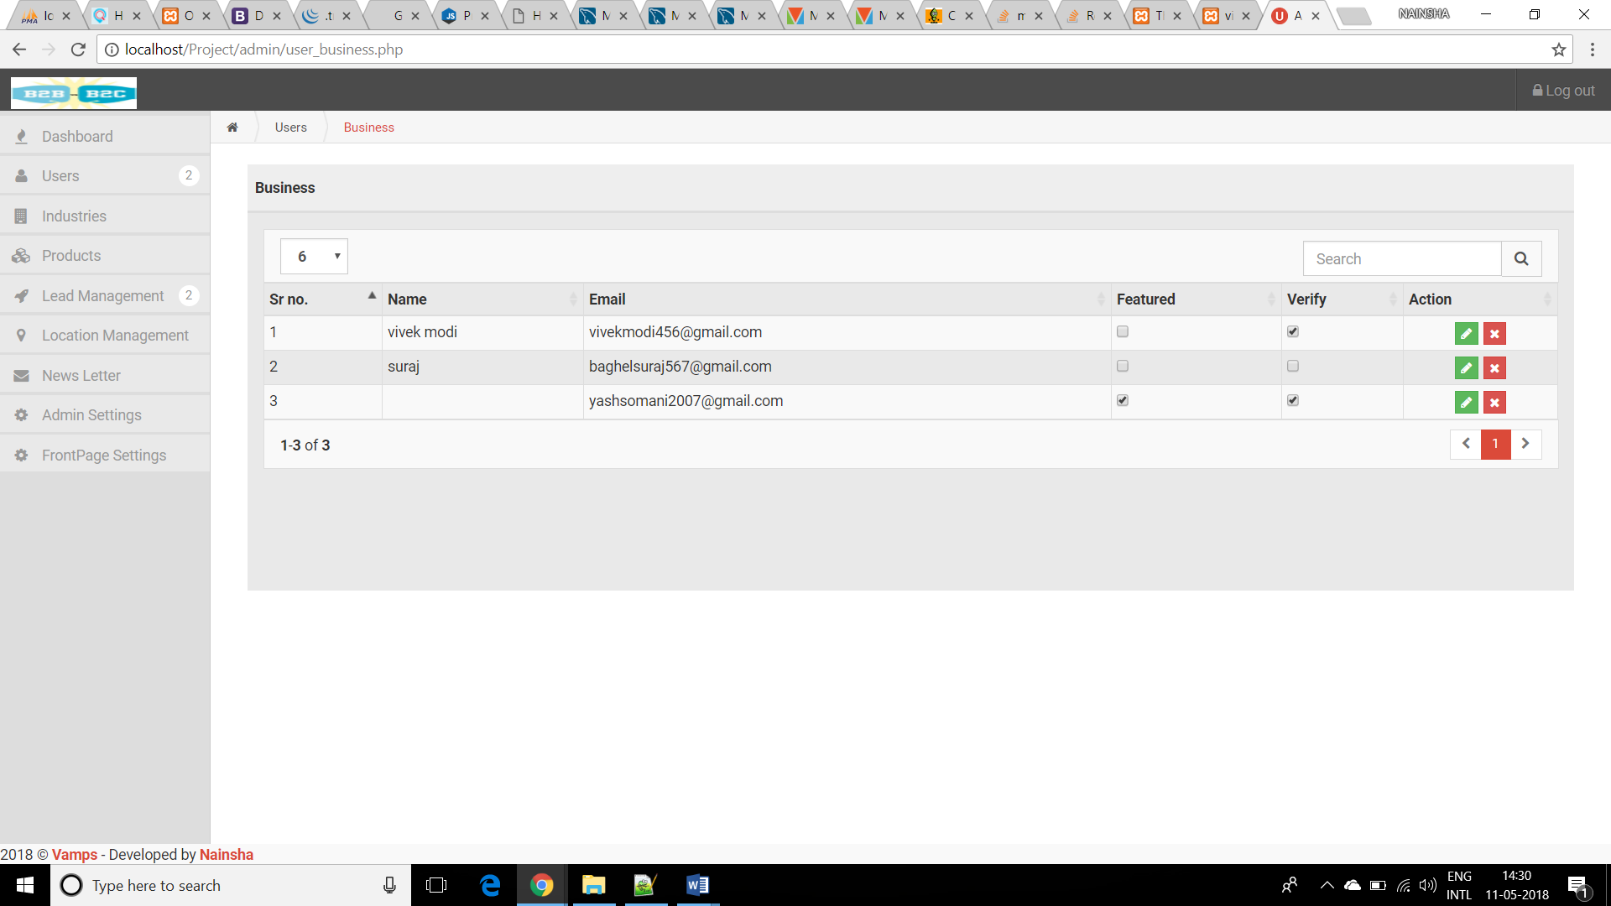

# Industries

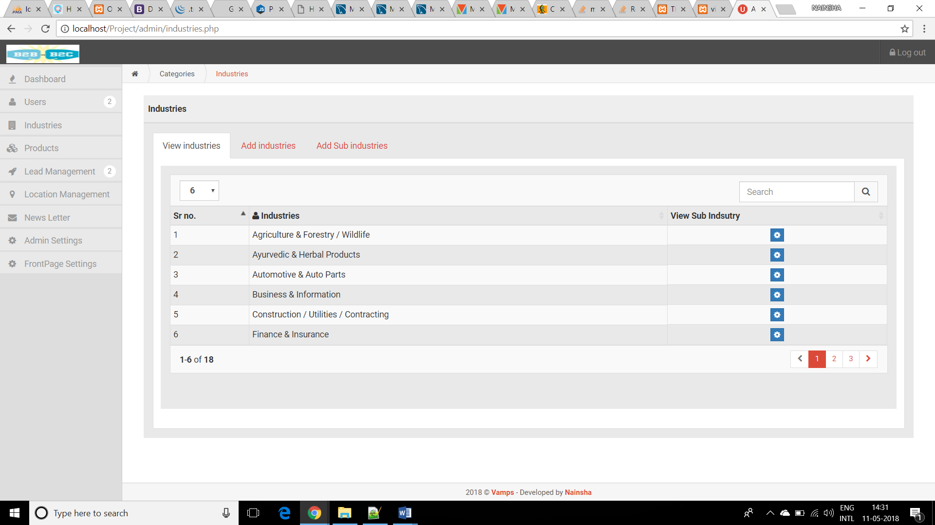

# Admin Settings

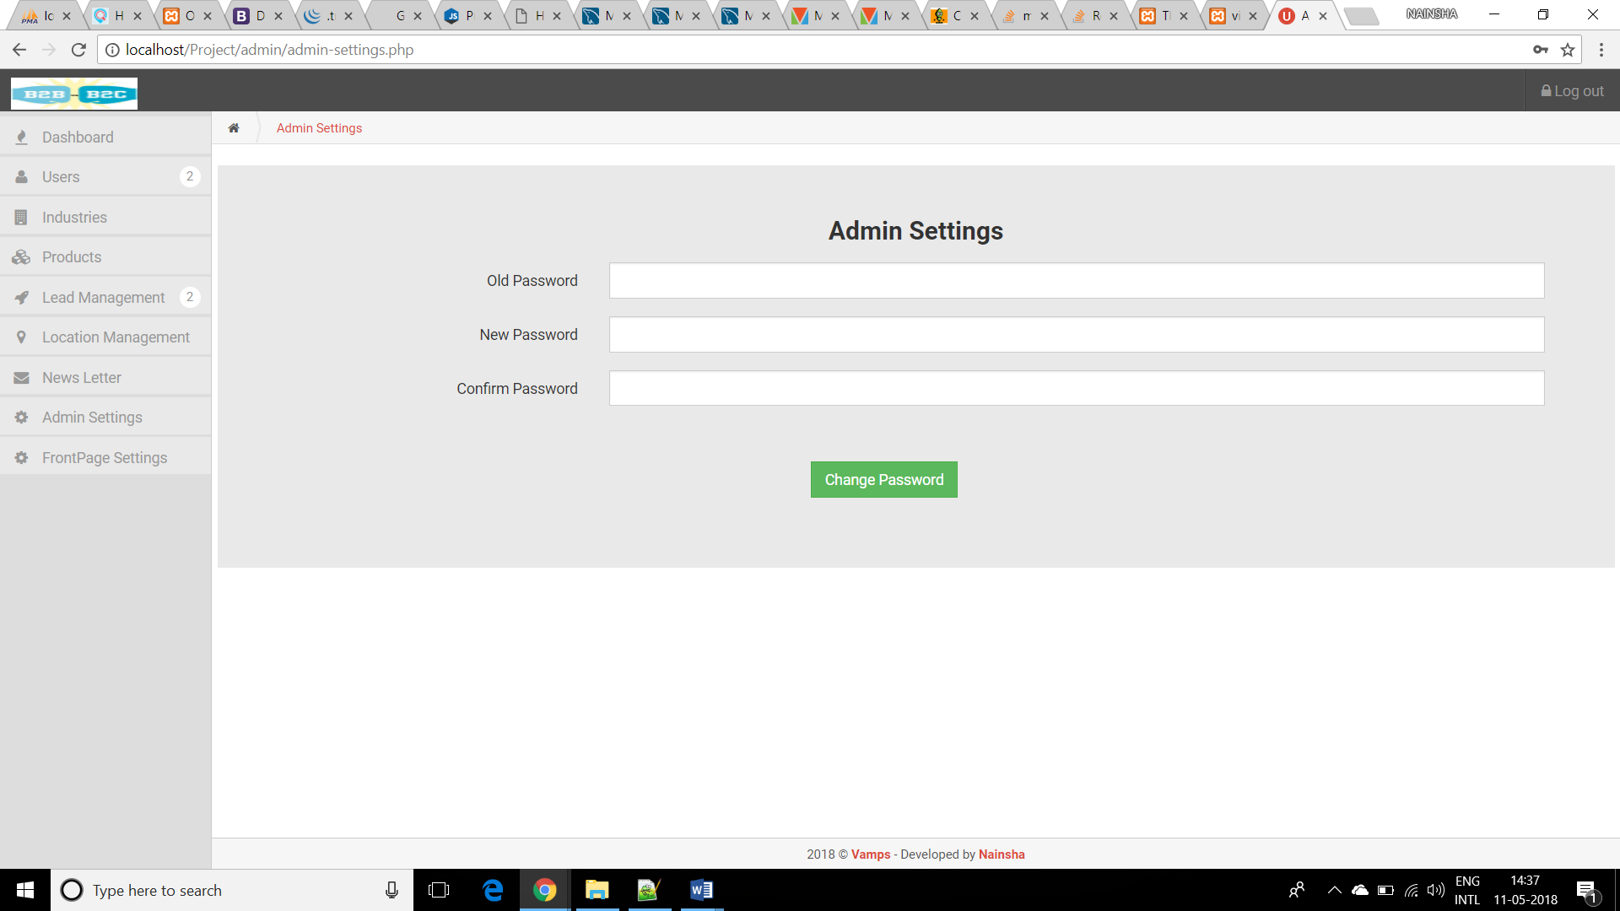

# News Letter

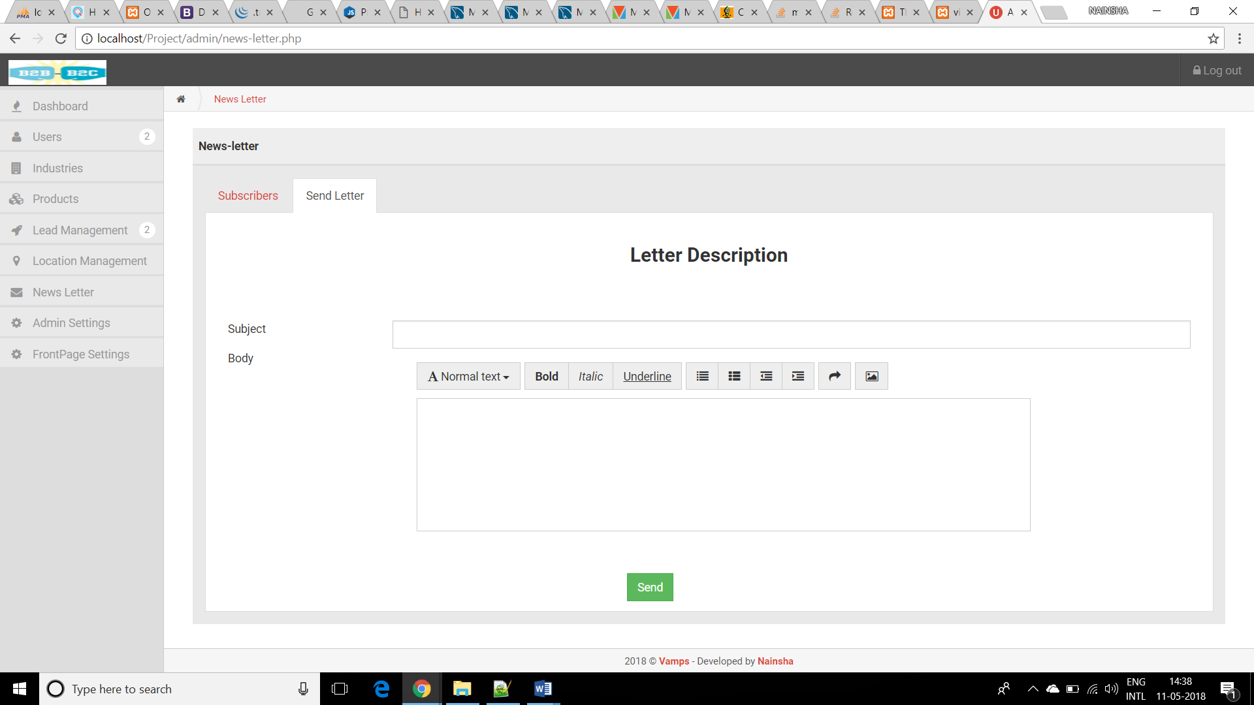

# Front Page Settings

# 

# Location Management

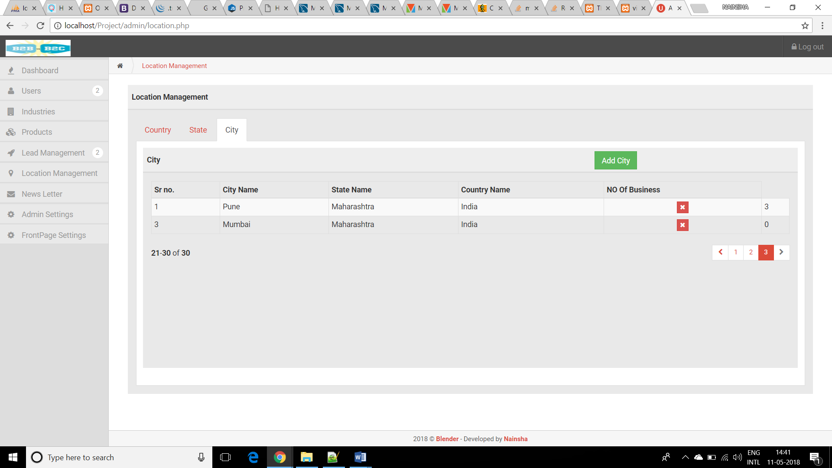

# Products

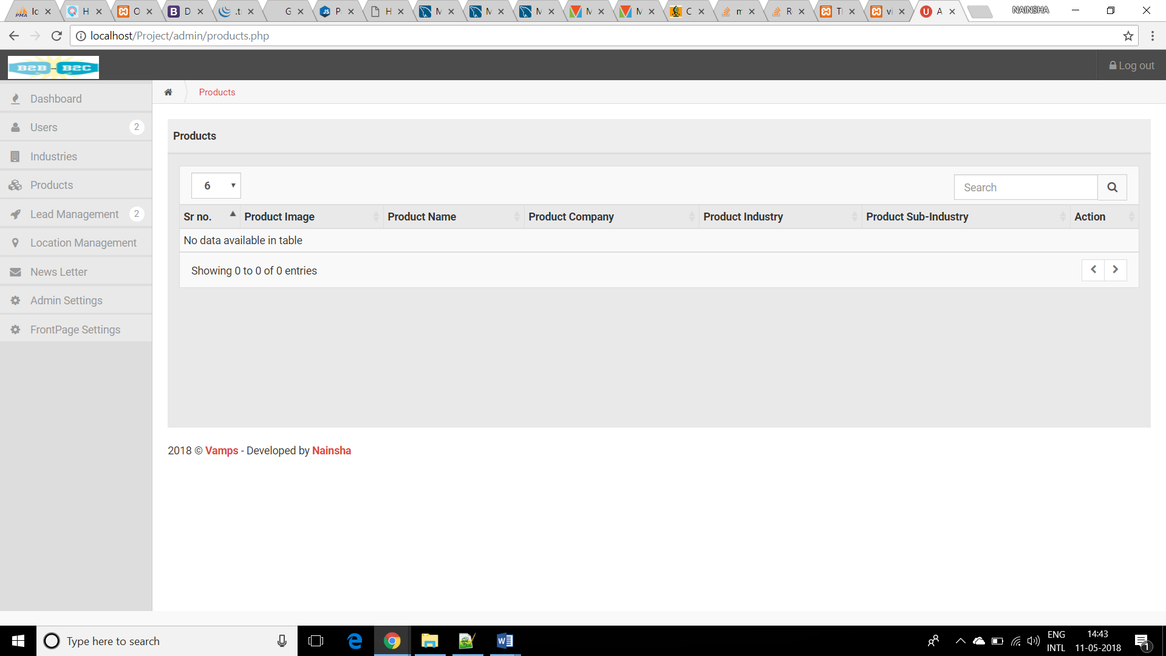

# Lead Management

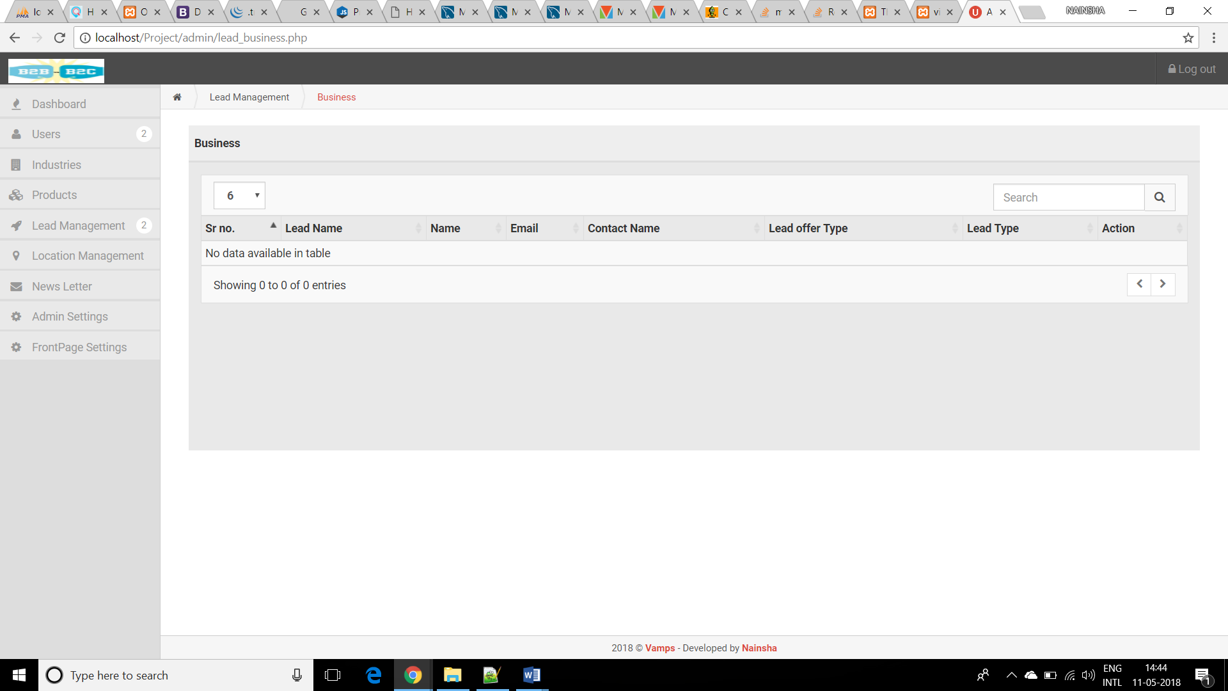

# Login Page

# 

# Forgot Password

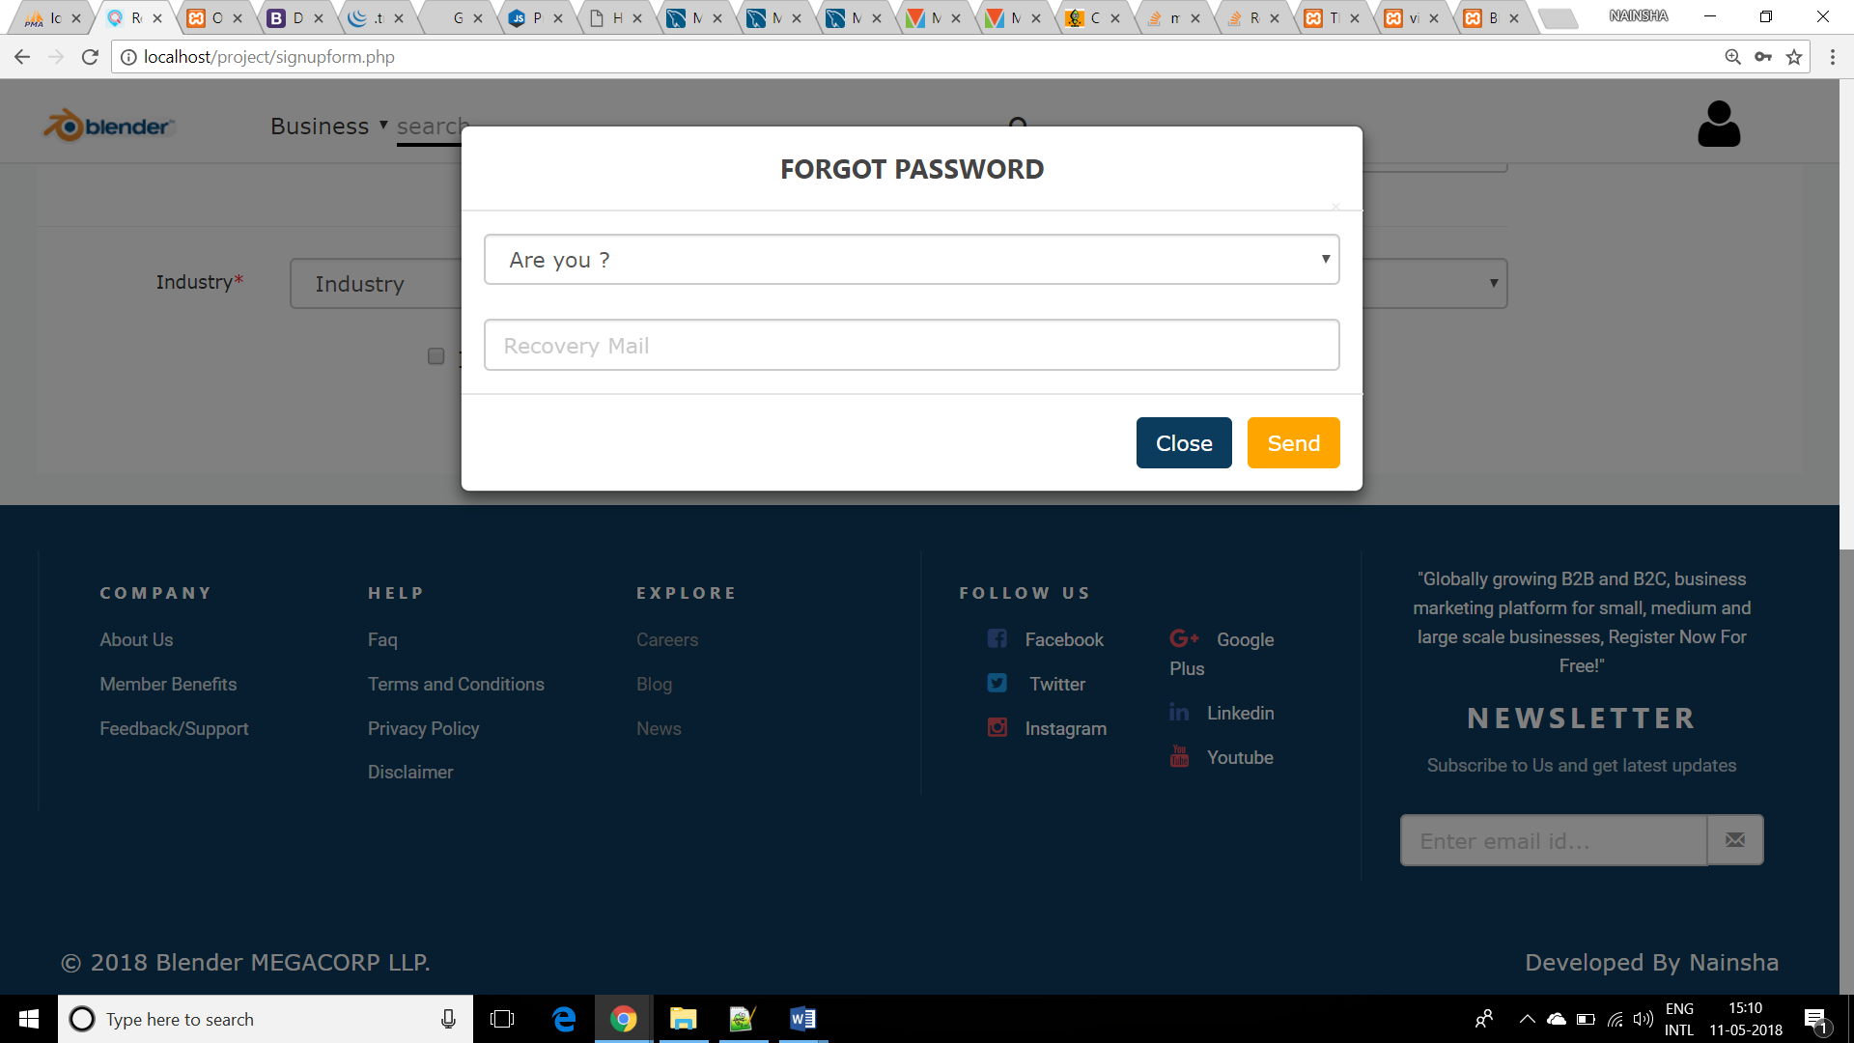

# Sign Up Page (Business Owner)

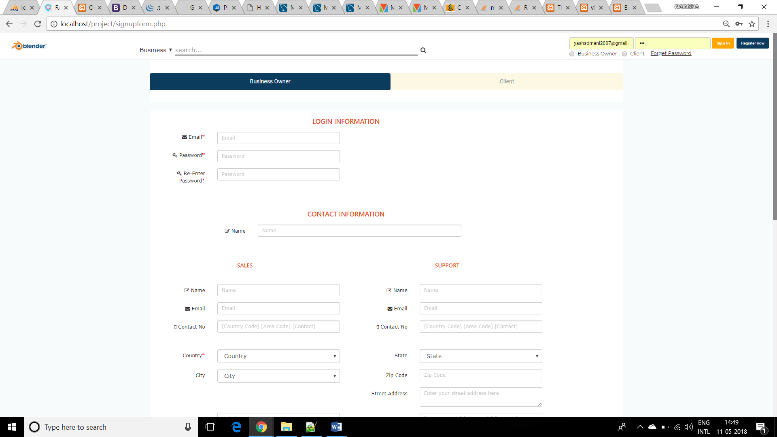

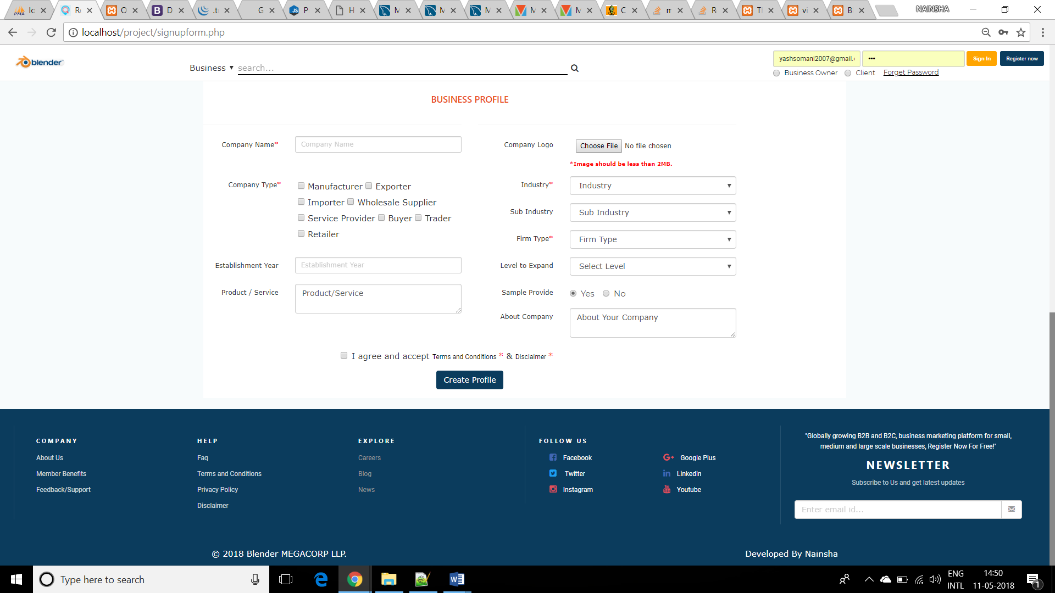

# Sign Up Page (Client)

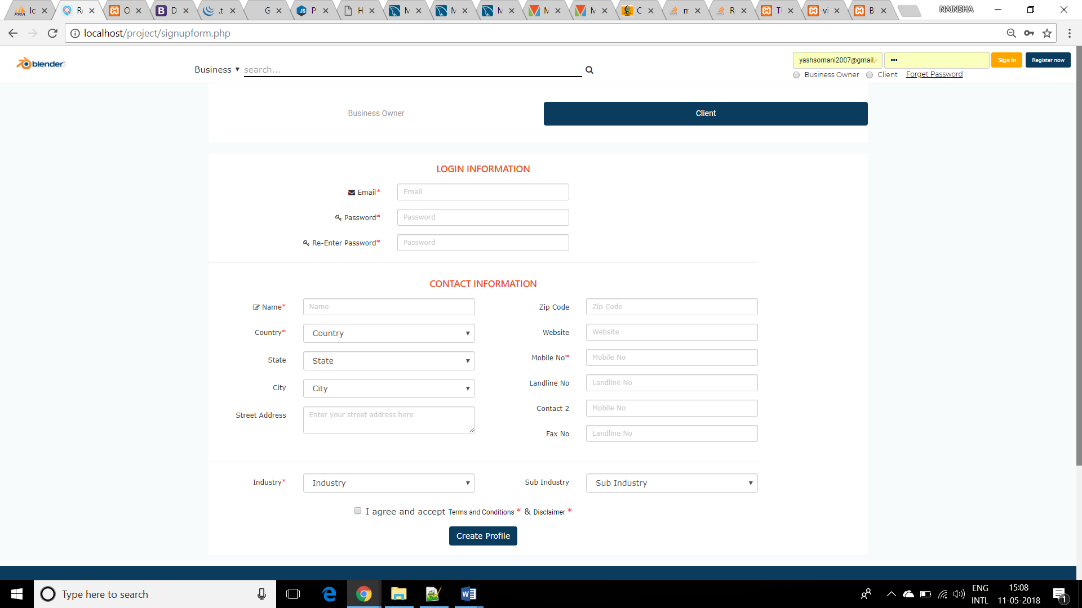

# Home Page (Main)

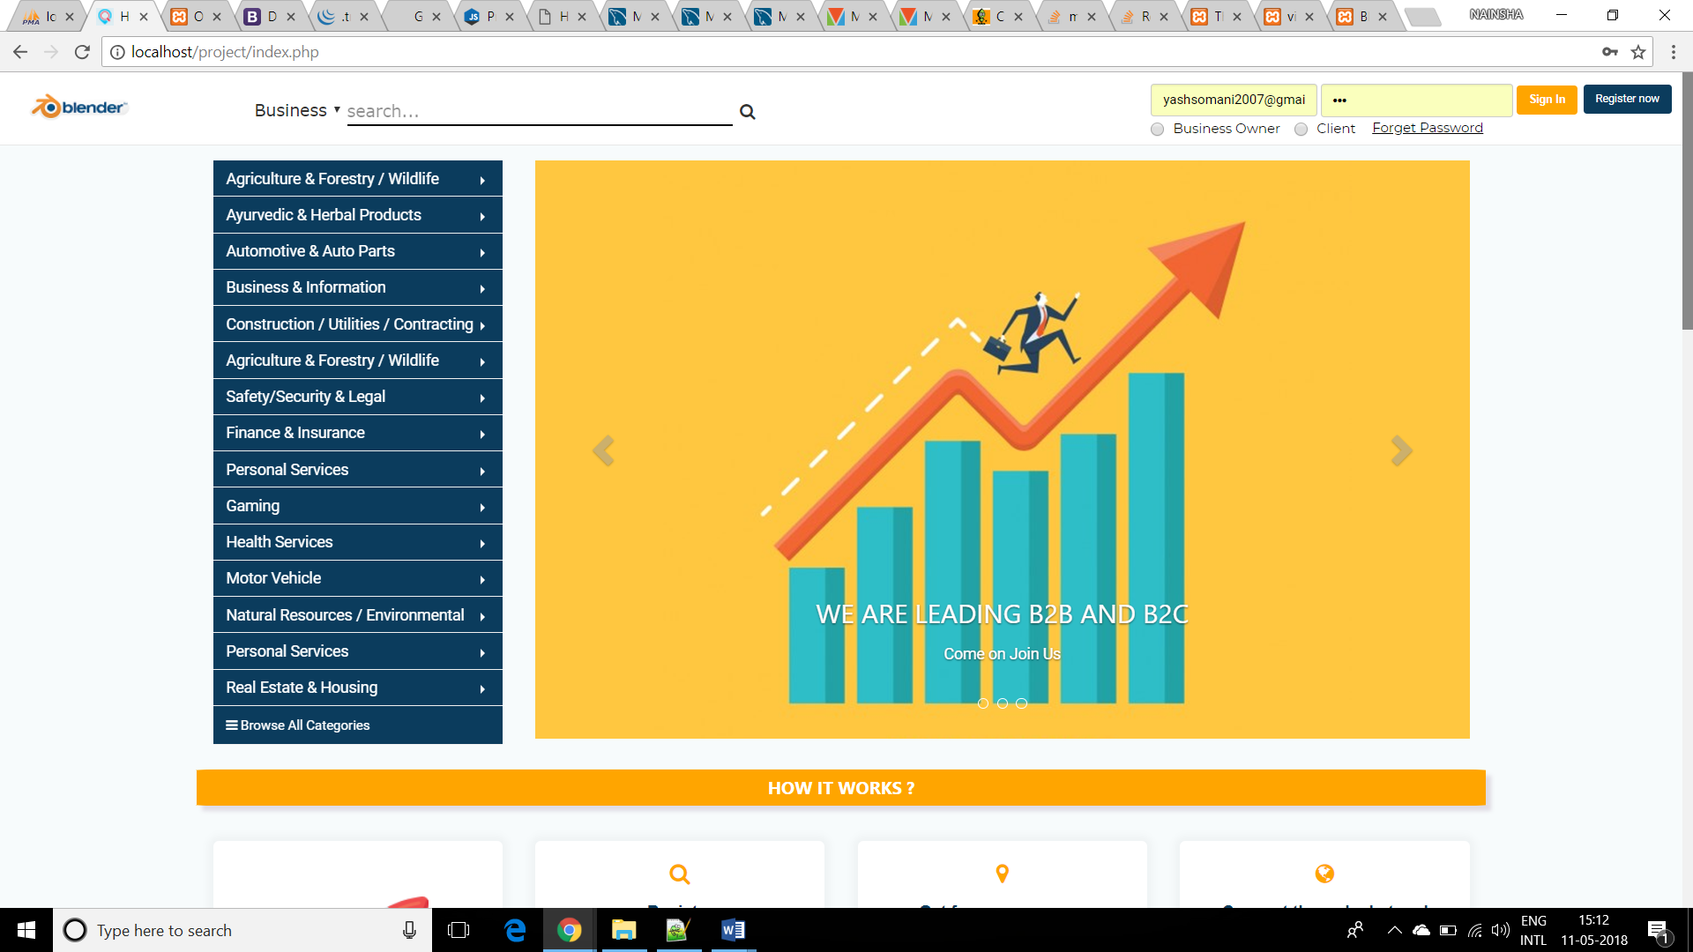

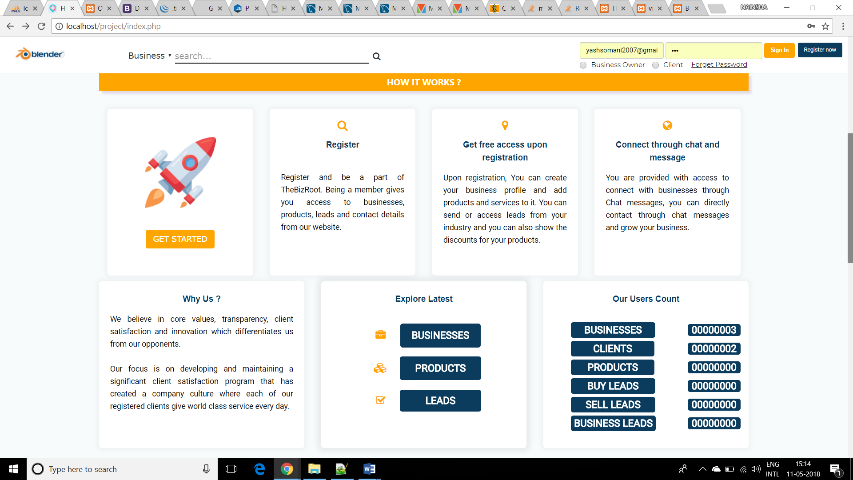

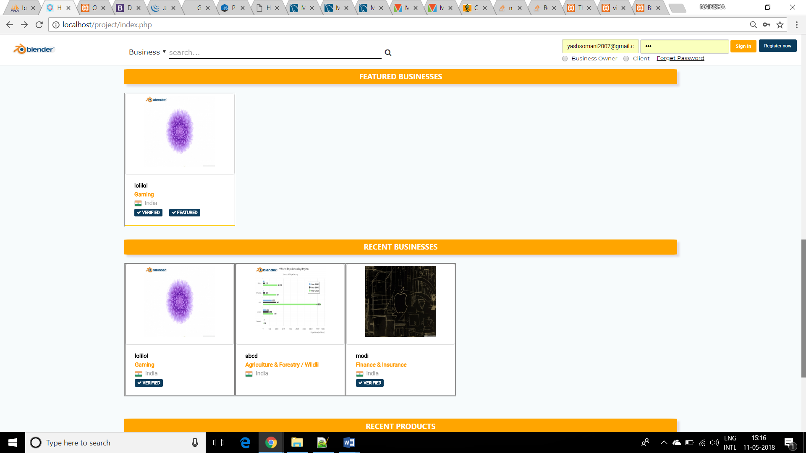

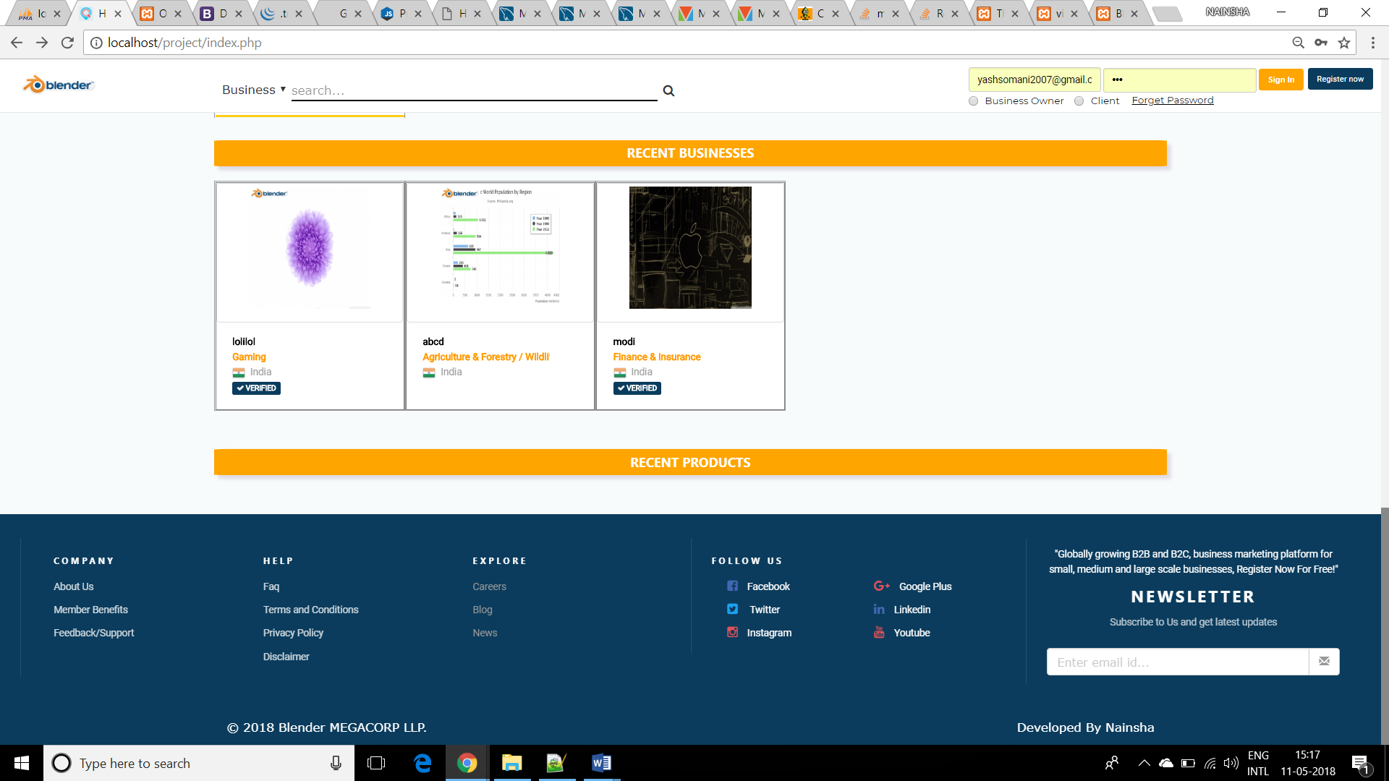

# Business Owner profile

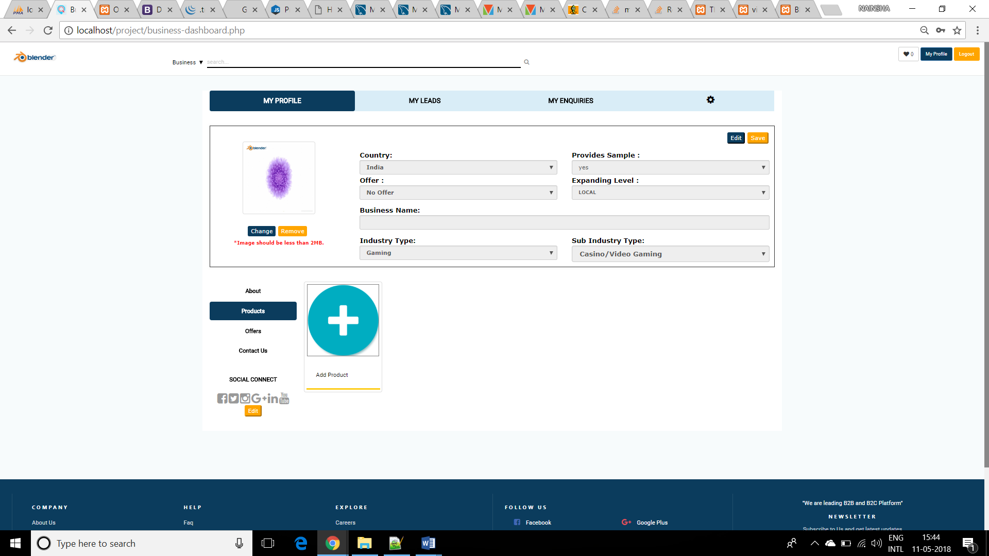

# ADD Product

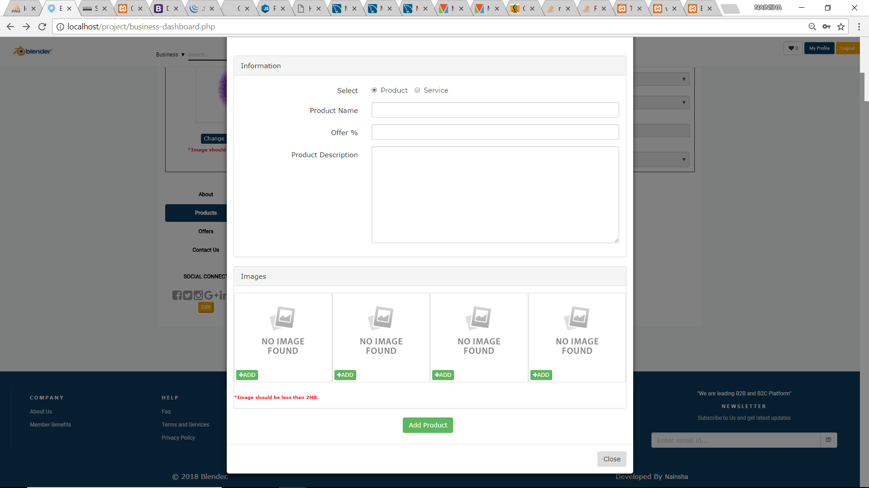

# My Leads

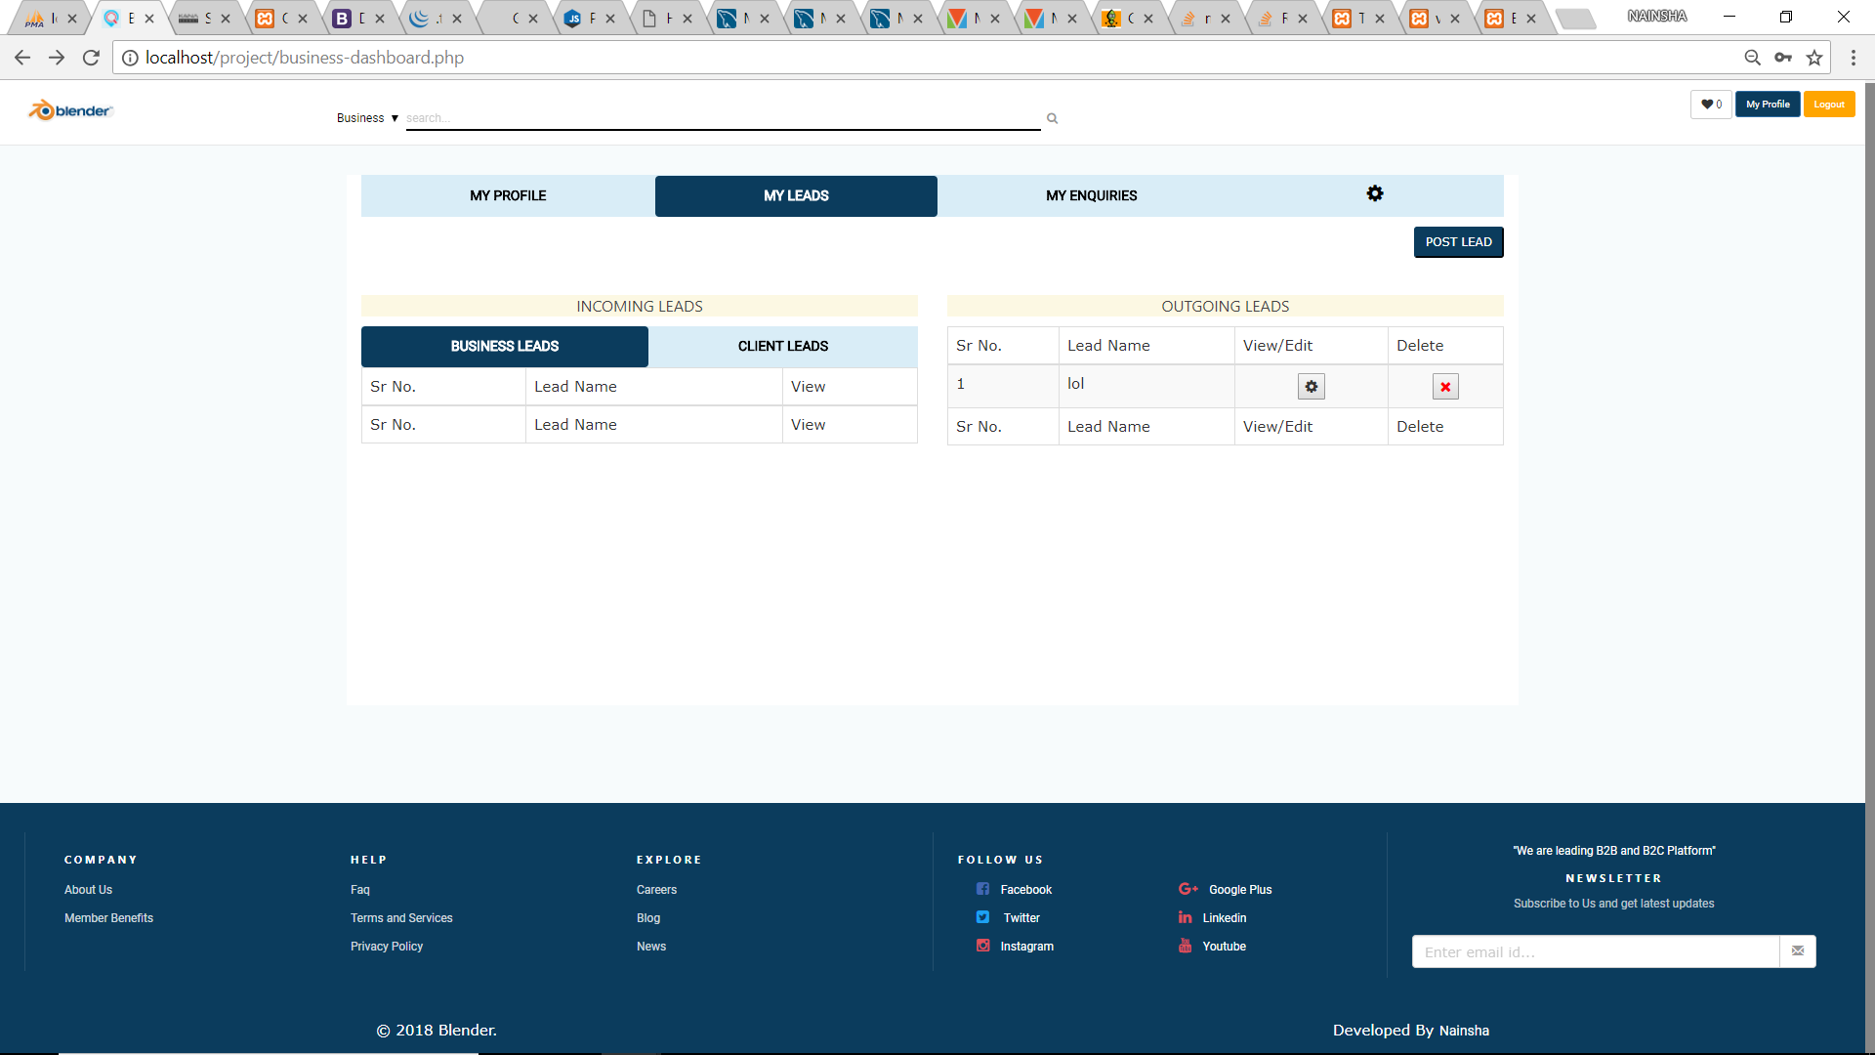

Post Leads

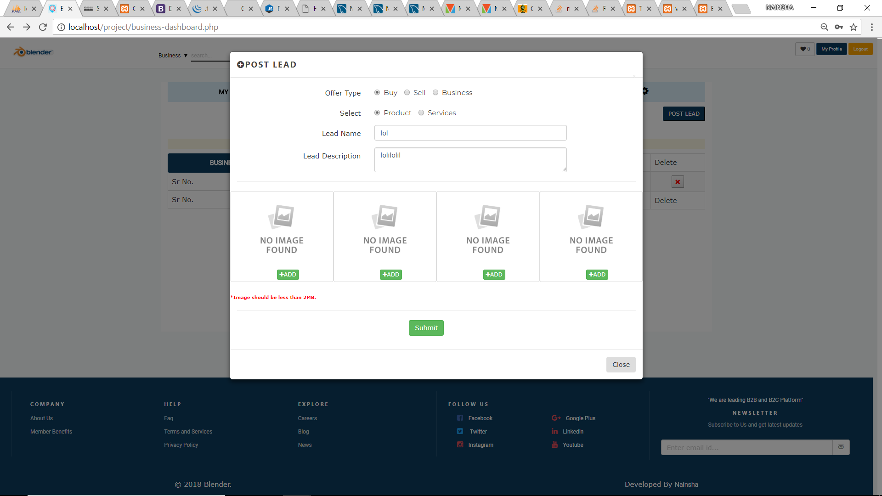

# My Enquiries

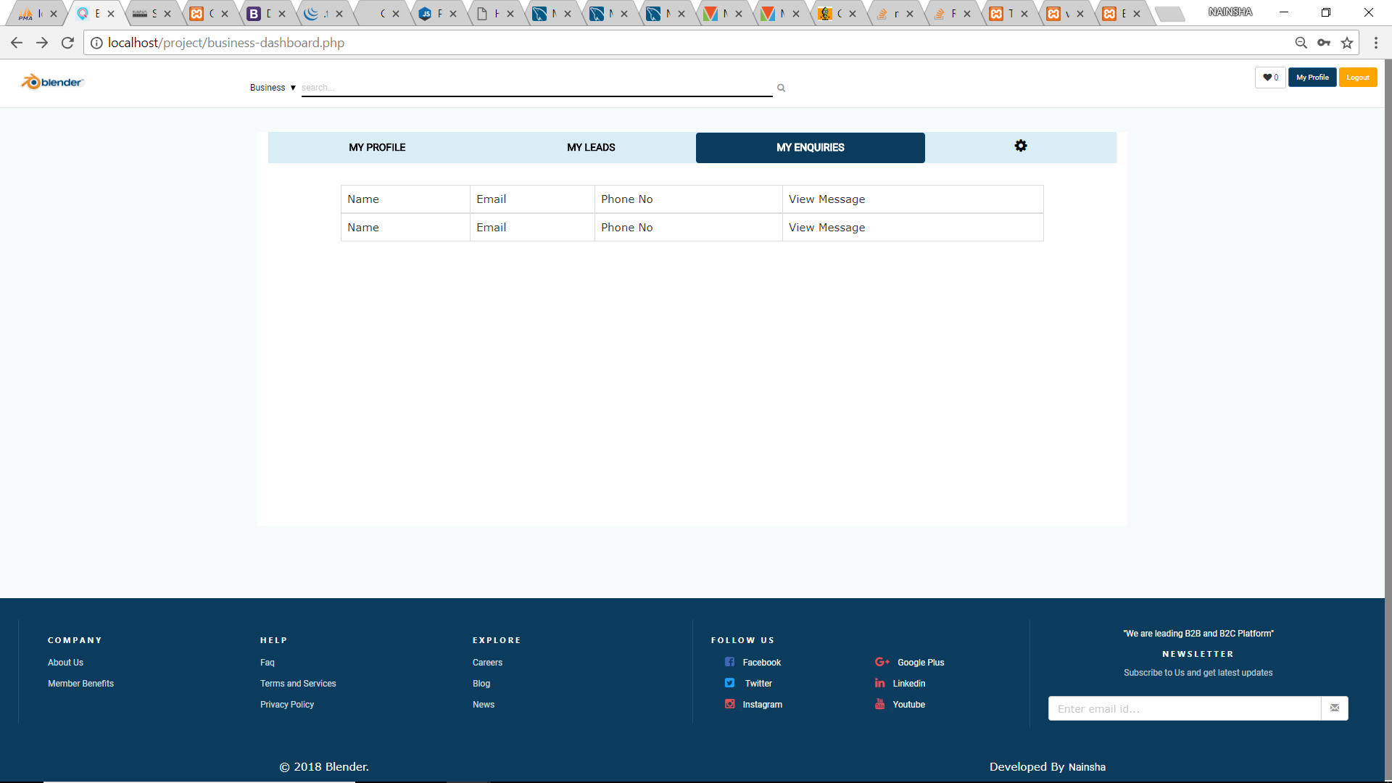

# Account Settings

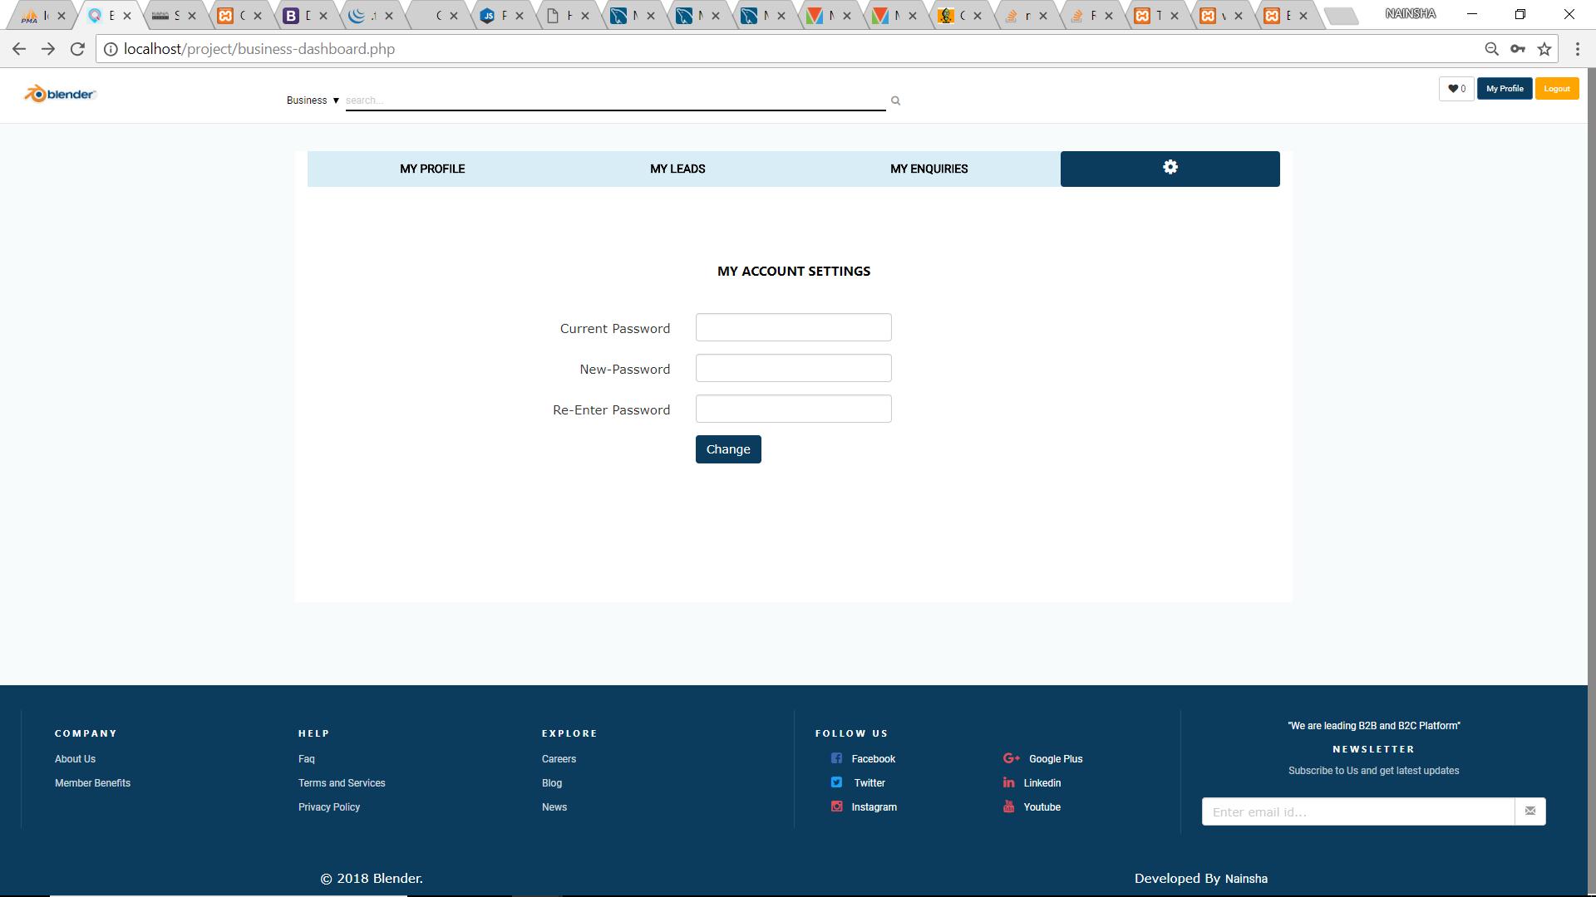

# Contact Us

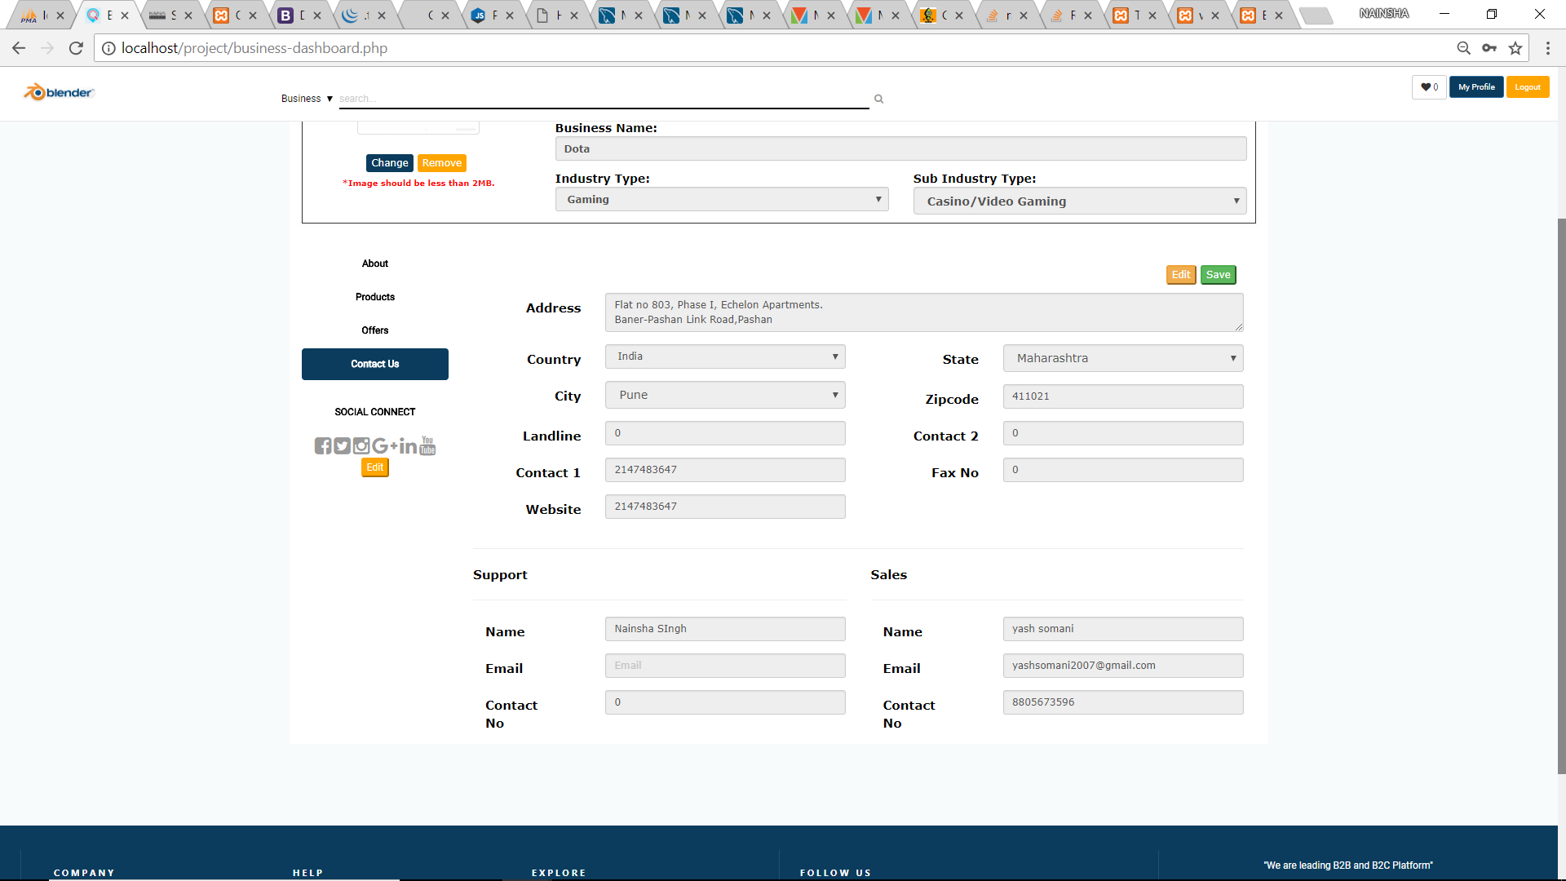

# Report Error

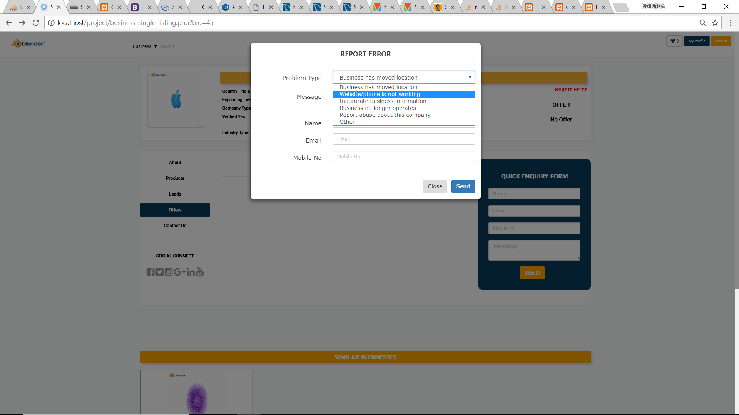

# Wishlist

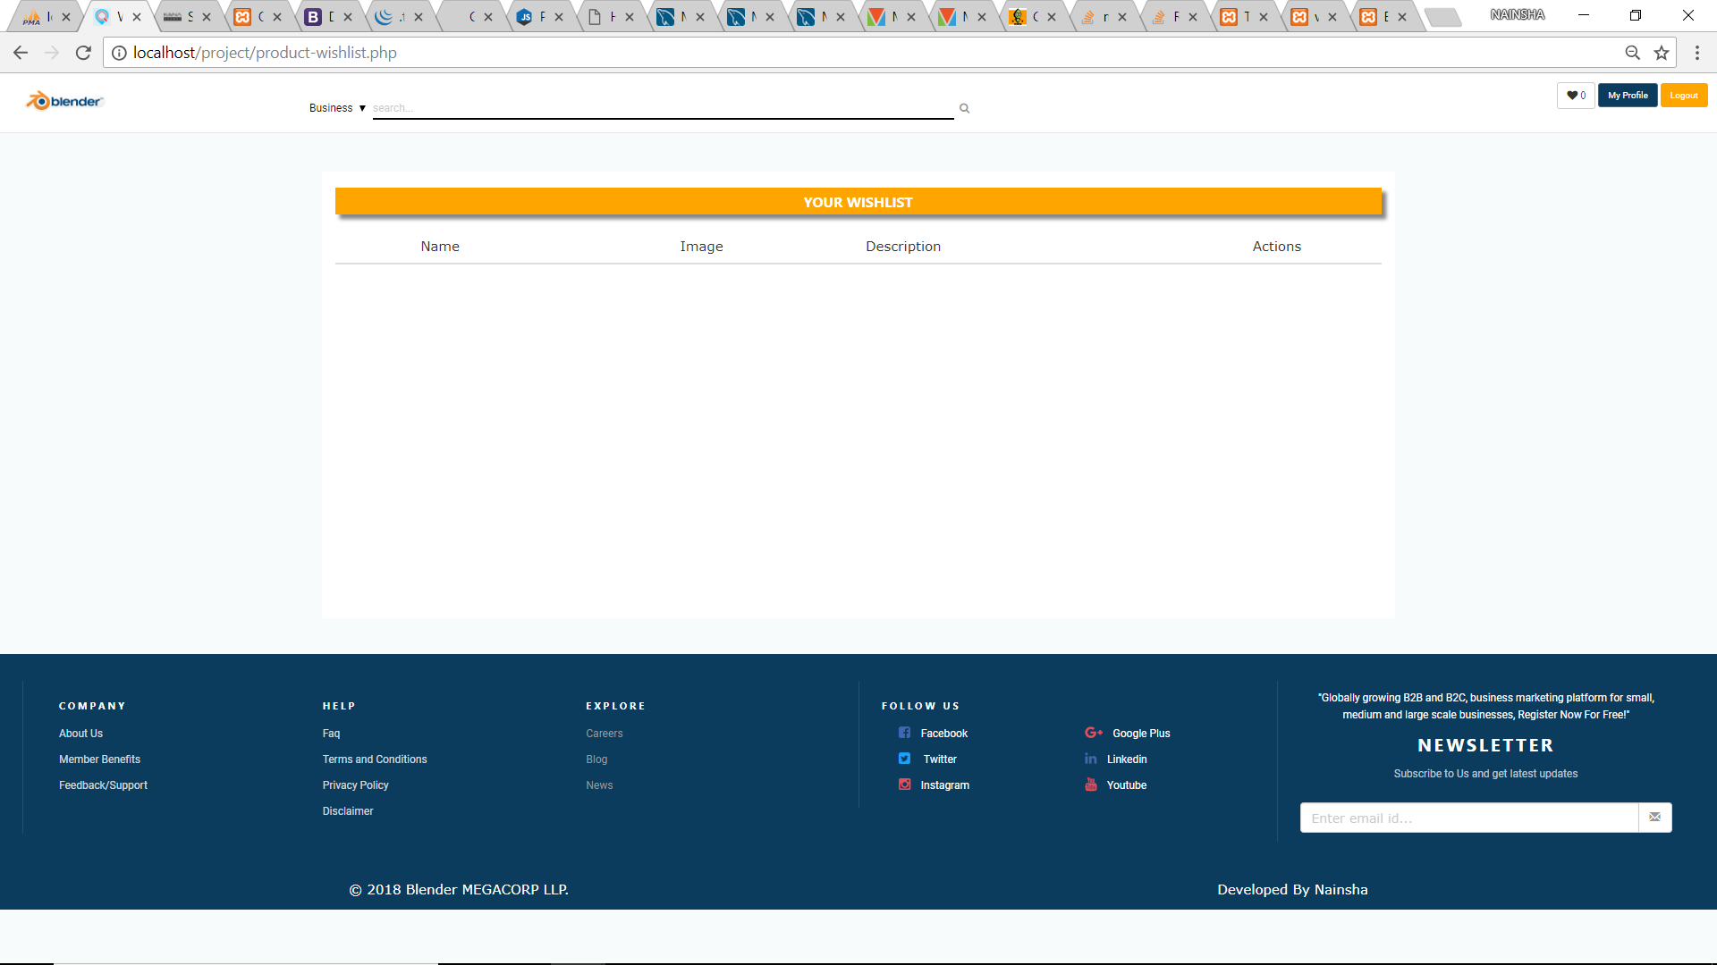

# CLIENT OWNER (Home Page)

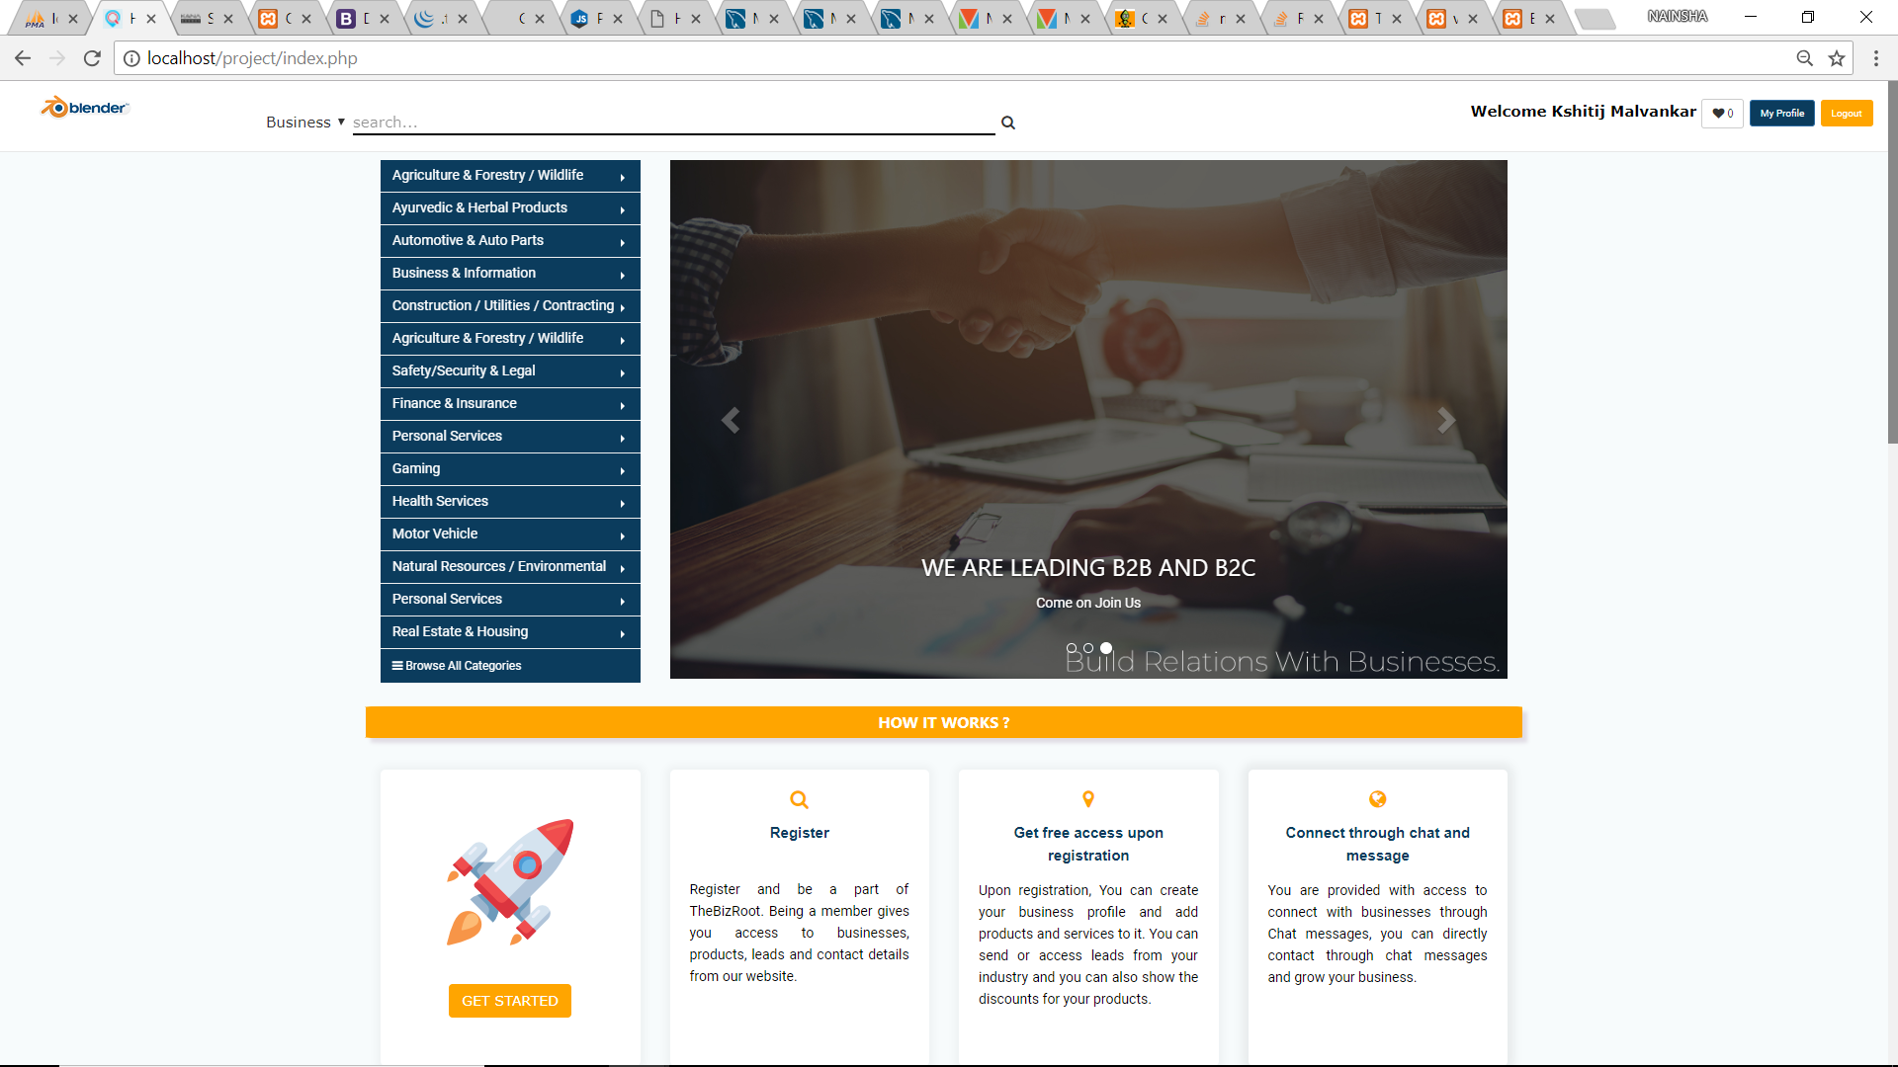

# My Profile

# 

# My Leads

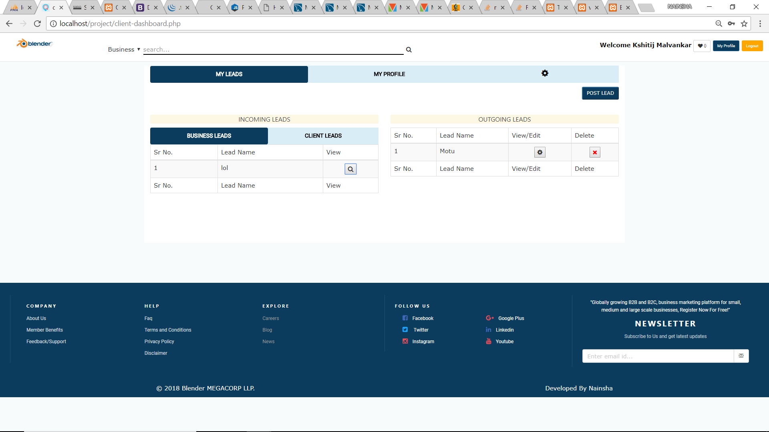

# View Business Lead

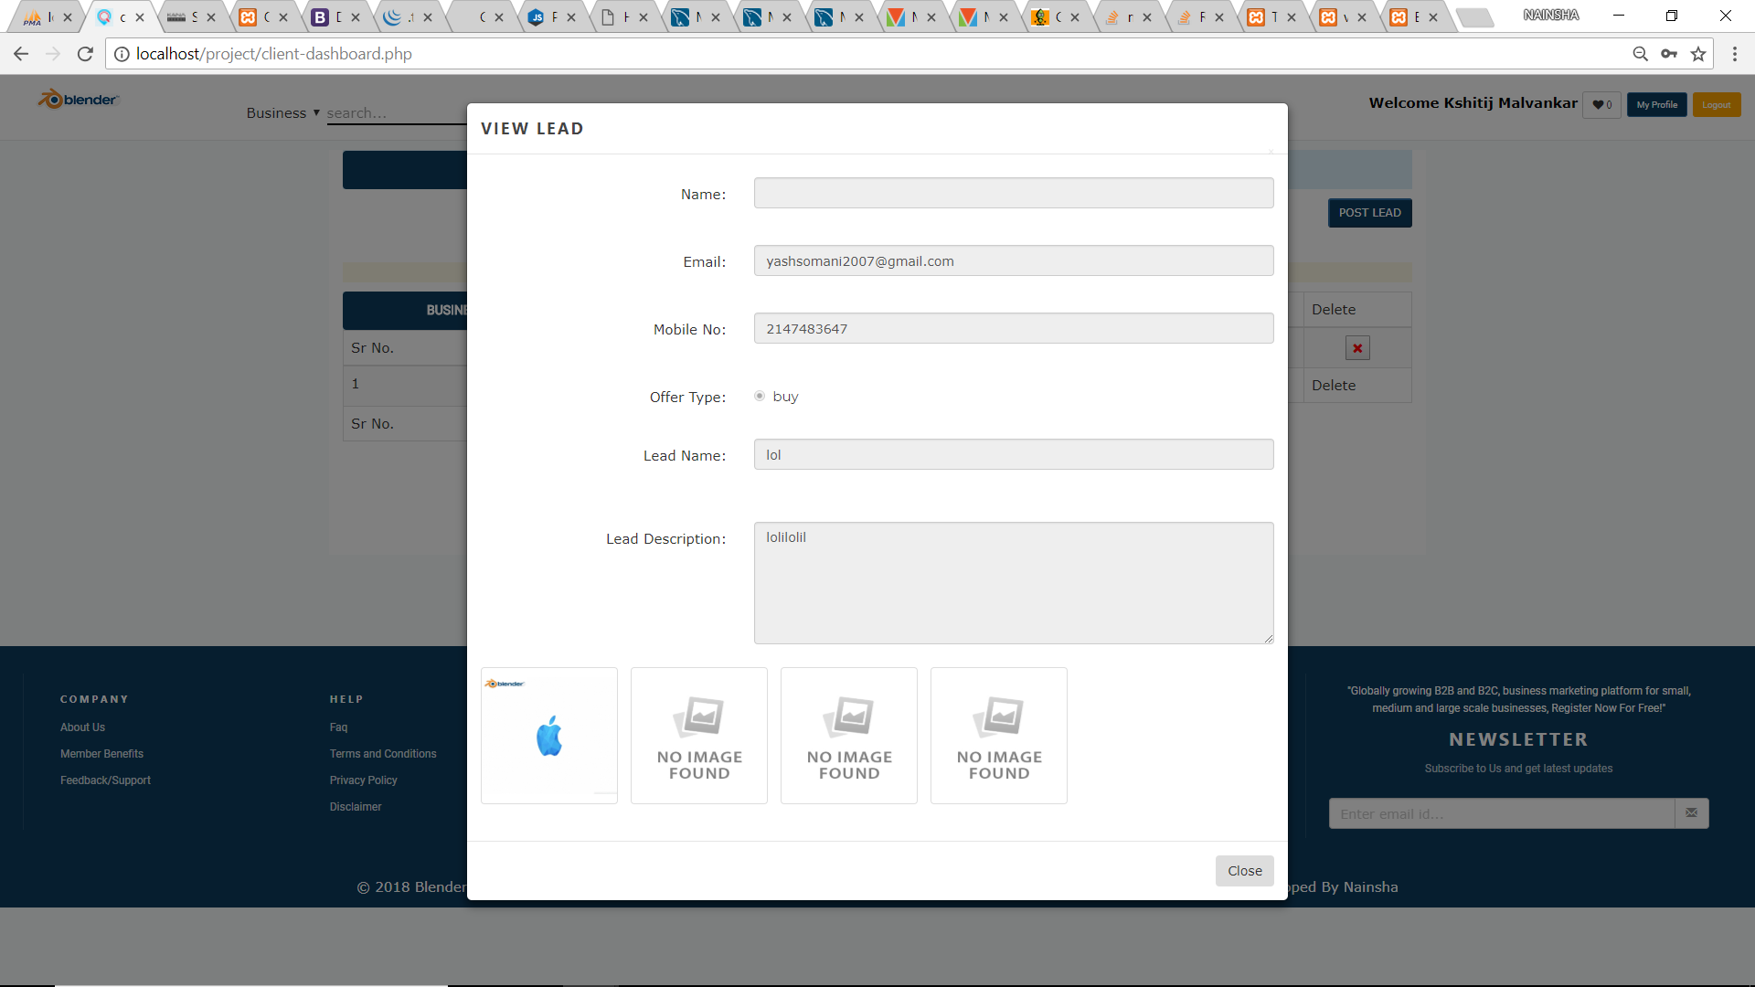

# Edit Lead

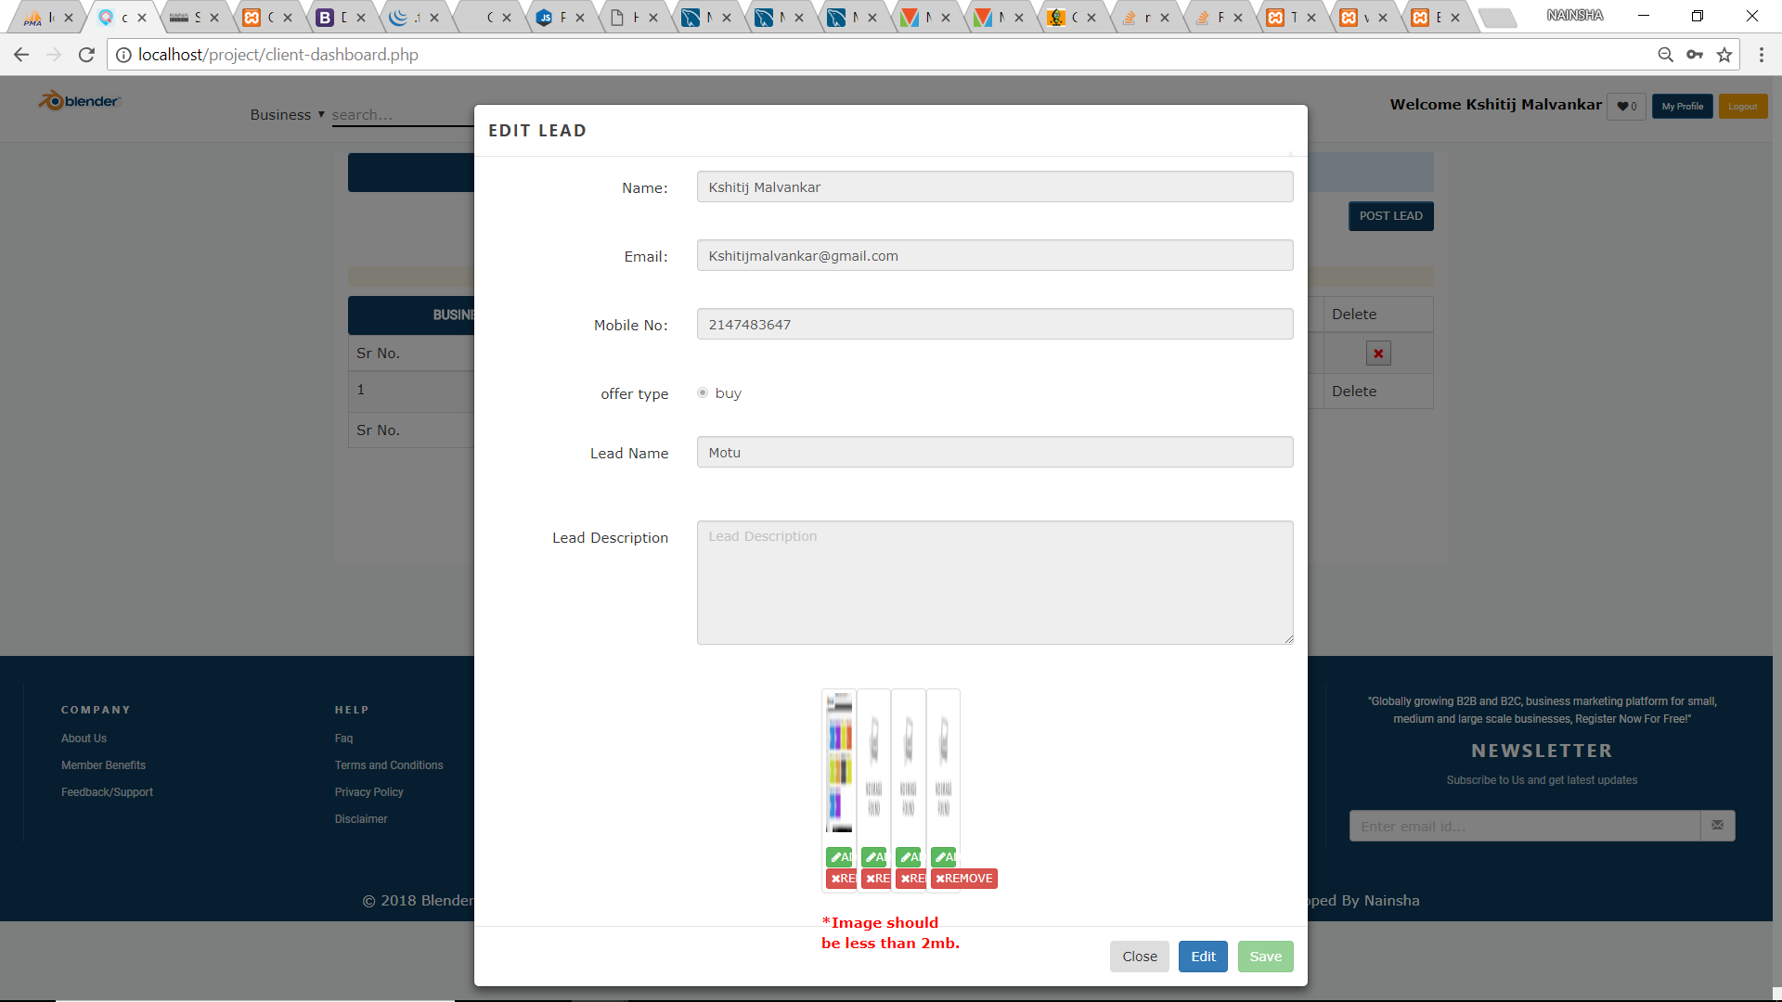

# Post Lead

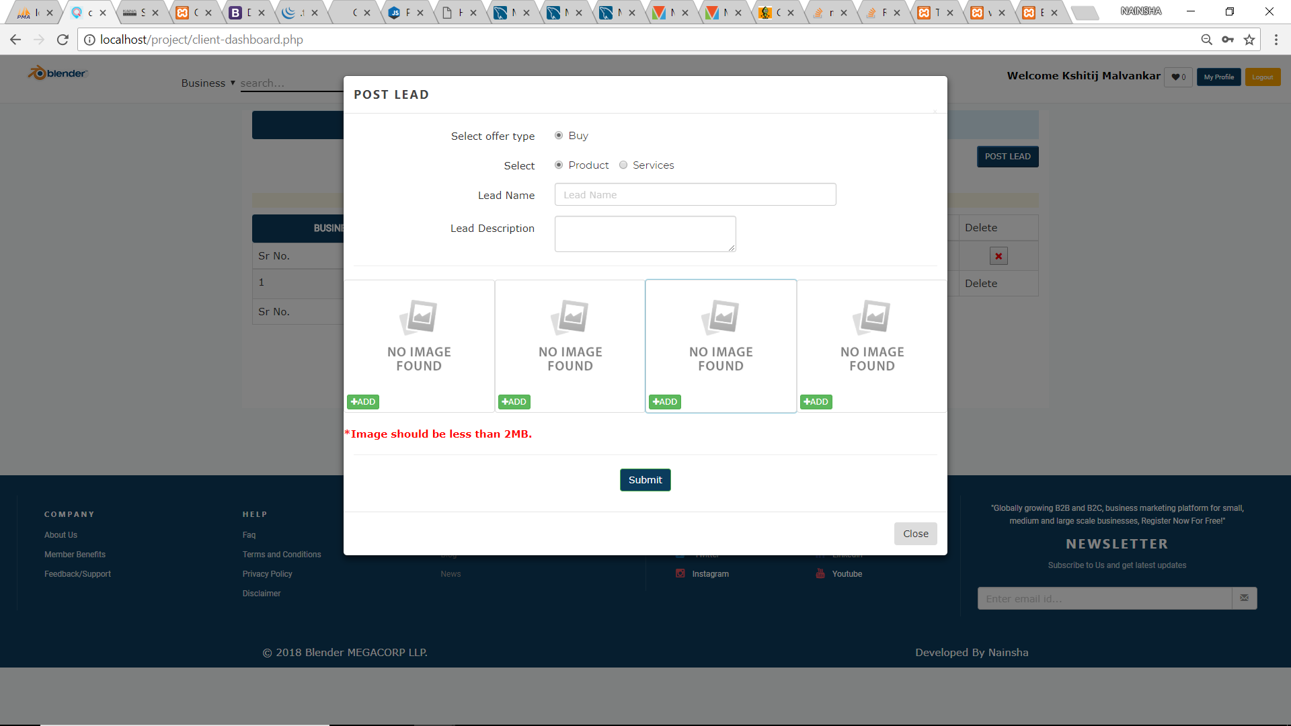

# Account Settings

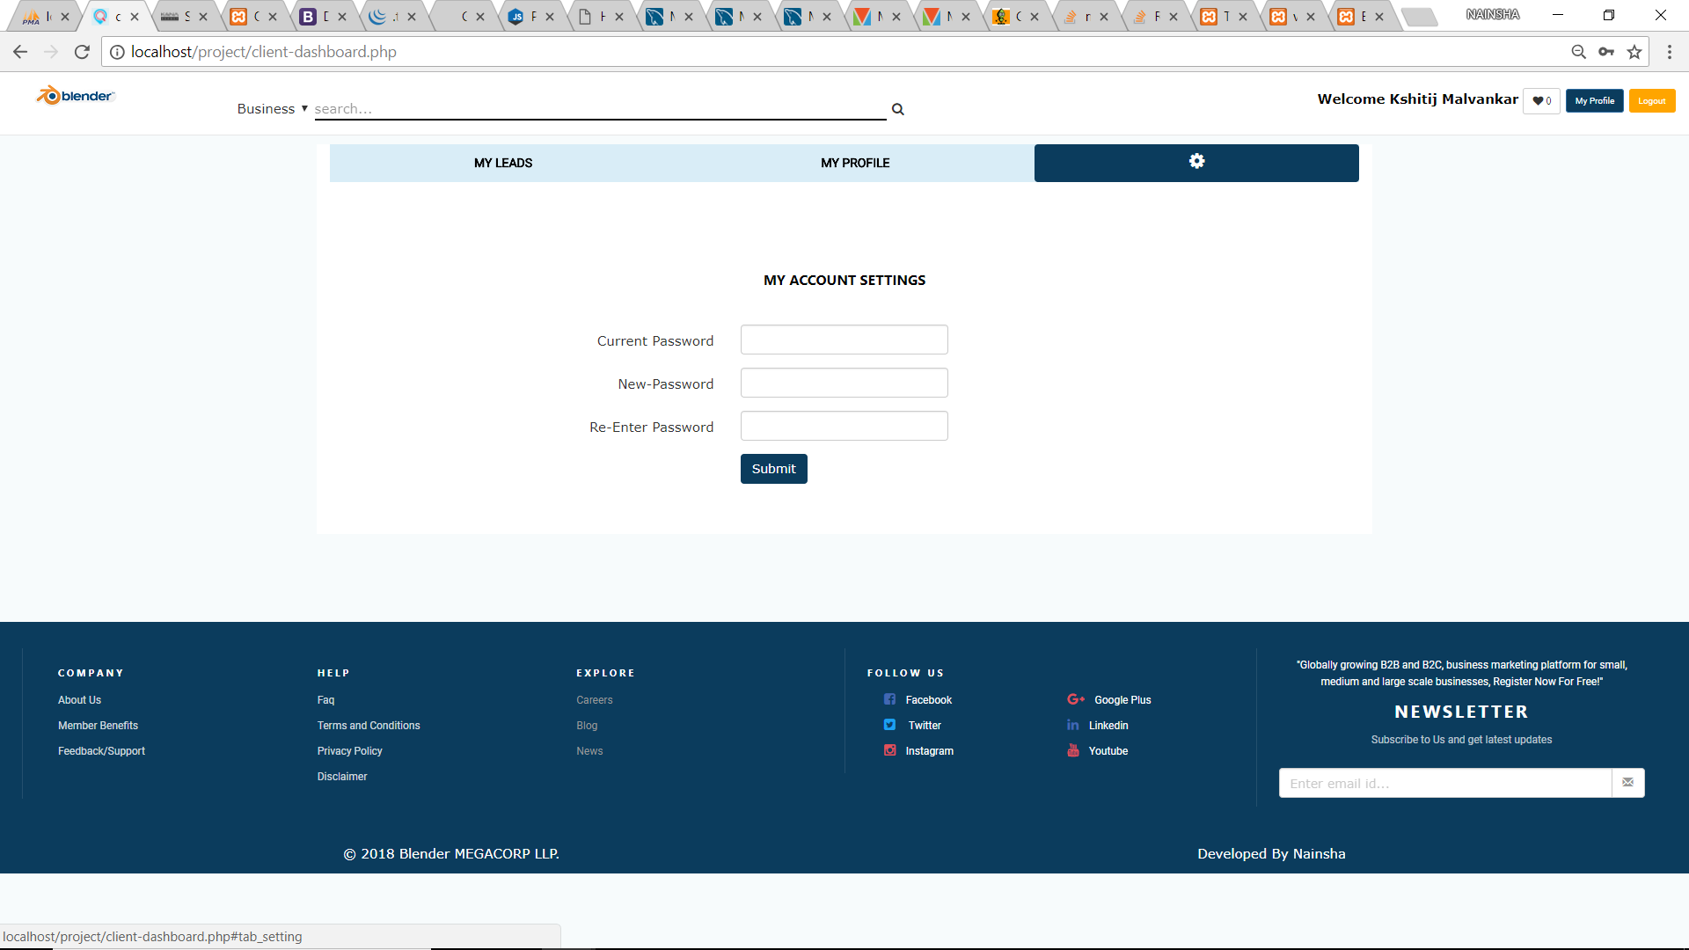

# Report Error

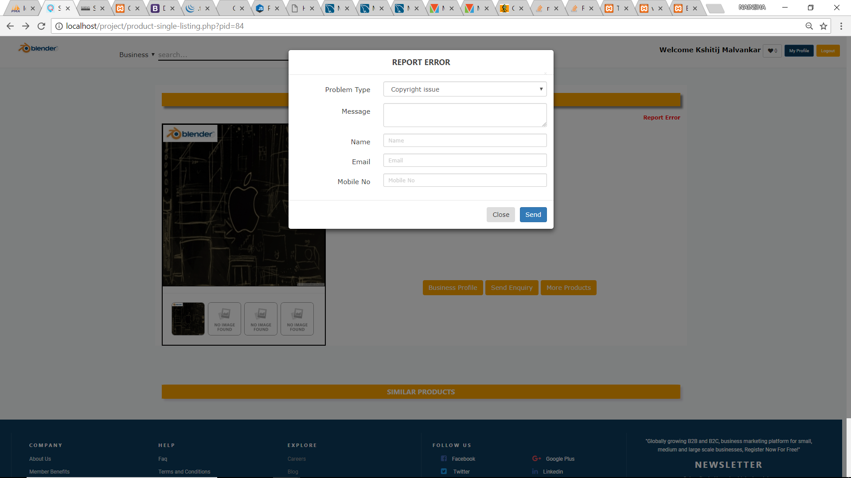

# Send Enquiry

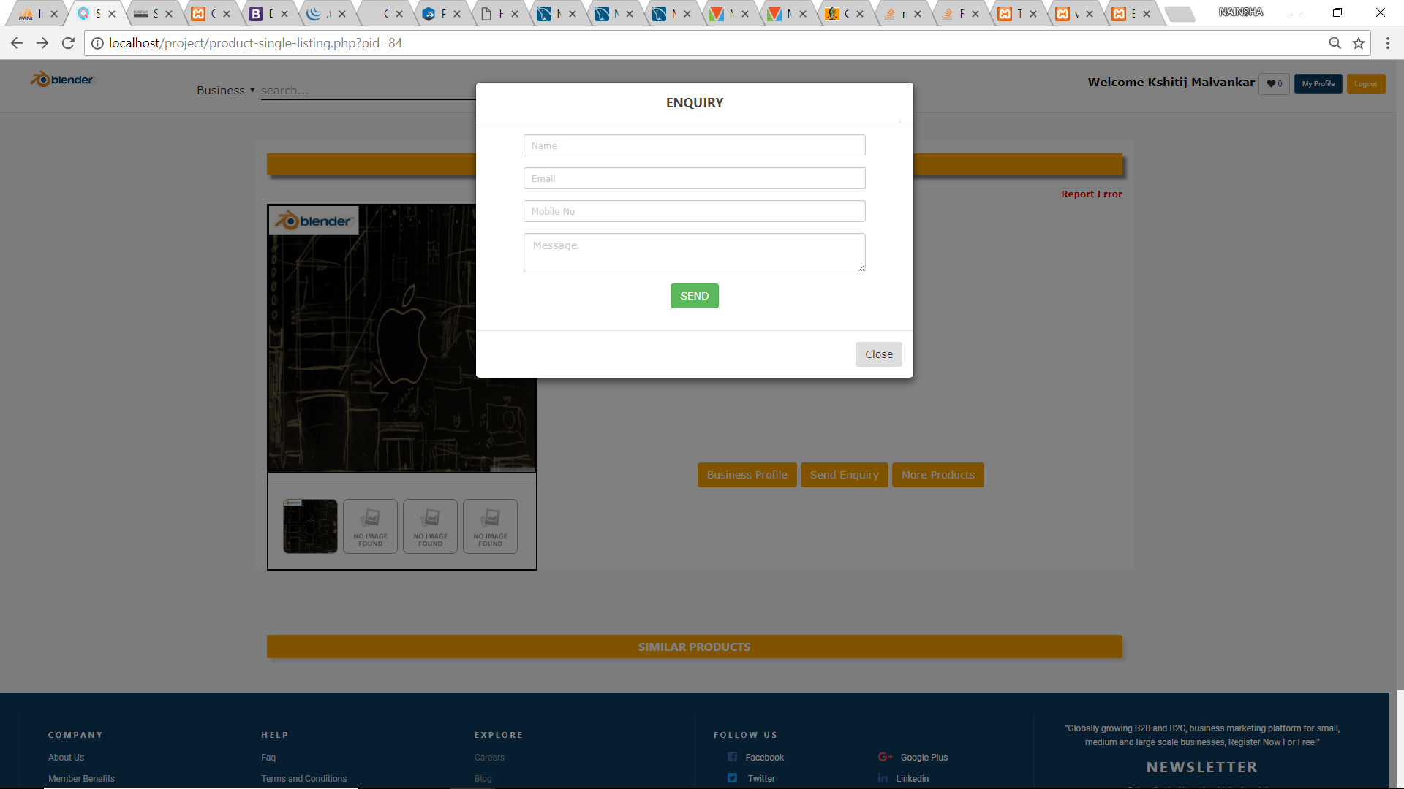

 ***CONCLUSION***

Conclusion

In my Project entitled “**Business-to-business(b2b)platform**” I have tried my best to fulfill all the requirements of B2B Platform. The project being simple and flexible is running successfully. The main advantage of our project is that its simplicity attracts a lot of users. It can be easily run by a novice user.

This project when implemented it will remove all the security issues. Also, there will be speedy and secured authentication procedure for the maintenance of records. Data entry is fast and simple because it automatically picks up information about a customer from the database on subsequent visits.

Therefore, our software will definitely prove to be a successful stepping stone in replacing the outdated manual method of maintaining secure records. The work plan also includes the detailed features of the technology used in the project defining the front end and back end. The objectives and scope of the project in future have been elaborated.